Electrical system form FS2019

Ain Shams University / University of Sussex

SAR Electric (Sussex Ain Shams Racing Electric)

CAR Number: 60

Contact Person: Email:

* **Main Team Contact for ESF related questions**

Feel free to add team logo, car picture etc.

The table of contents must be hyperlinked.

The generated PDF must contain hyperlinked bookmarks

Use internal reference links. For example when describing wiring and mentioning a figure in the text then link it to the figure.

Table of Contents

Table of Contents ii

I List of Figures vi

II List of Tables vii

III List of Abbreviations viii

1 System Overview 1

2 Electrical Systems 2

2.1 Shutdown Circuit 2

2.1.1 Description/concept 2

2.1.2 Wiring / additional circuitry 2

2.1.3 Position in car 3

2.2 IMD 3

2.2.1 Description (type, operation parameters) 3

2.2.2 Wiring/cables/connectors/ 3

2.2.3 Position in car 4

2.3 Inertia Switch 4

2.3.1 Description (type, operation parameters) 4

2.3.2 Wiring/cables/connectors/ 4

2.3.3 Position in car 4

2.4 Brake System Plausibility Device 4

2.4.1 Description/additional circuitry 4

2.4.2 Wiring 5

2.4.3 Position in car/mechanical fastening/mechanical connection 5

2.4.4 Wiring/cables/connectors/ 5

2.4.5 Position in car 5

2.4.6 Testing Method 5

2.5 Reset / Latching for IMD and BMS 5

2.5.1 Description/circuitry 5

2.5.2 Wiring/cables/connectors 5

2.5.3 Position in car 6

2.6 Shutdown System Interlocks 6

2.6.1 Description/circuitry 6

2.6.2 Wiring/cables/connectors 6

2.6.3 Position in car 6

2.7 Tractive system active light 6

2.7.1 Description/circuitry 6

2.7.2 Wiring/cables/connectors 6

2.7.3 Position in car 7

2.8 Measurement points 7

2.8.1 Description 7

2.8.2 Wiring, connectors, cables 7

2.8.3 Position in car 7

2.9 Pre-Charge circuit 7

2.9.1 Description 7

2.9.2 Wiring, cables, current calculations, connectors 7

2.9.3 Position in car 8

2.10 Discharge circuitry 8

2.10.1 Description 8

2.10.2 Wiring, cables, current calculations, connectors 8

2.10.3 Position in car 9

2.11 HV Disconnect (HVD) 9

2.11.1 Description 9

2.11.2 Wiring, cables, current calculations, connectors 9

2.11.3 Position in car 9

2.12 Ready-To-Drive-Sound (RTDS) 9

2.12.1 Description 9

2.12.2 Wiring, cables, current calculations, connectors 9

2.12.3 Position in car 9

3 Accumulator 11

3.1 Accumulator pack 1 11

3.1.1 Overview/description/parameters 11

3.1.2 Cell description 11

3.1.3 Cell configuration 12

3.1.4 Cell temperature monitoring 12

3.1.5 Accumulator insulation relays 12

3.1.6 Fusing 13

3.1.7 Battery management system 13

3.1.8 Accumulator indicator 14

3.1.9 Wiring, cables, current calculations, connectors 14

3.1.10 Charging 14

3.1.11 Mechanical Configuration/materials 15

3.1.12 Position in car 15

3.2 Accumulator pack 2 15

4 Energy meter mounting 16

4.1 Description 16

4.2 Wiring, cables, current calculations, connectors 16

4.3 Position in car 16

5 Motor controller 17

5.1 Motor controller 1 17

5.1.1 Description, type, operation parameters 17

5.1.2 Wiring, cables, current calculations, connectors 17

5.1.3 Position in car 18

5.2 Motor controller 2 18

6 Motors 19

6.1 Motor 1 19

6.1.1 Description, type, operating parameters 19

6.1.2 Wiring, cables, current calculations, connectors 19

6.1.3 Position in car 19

6.2 Motor 2 20

7 Torque encoder 21

7.1 Description/additional circuitry 21

7.2 Wiring 21

7.3 Position in car/mechanical fastening/mechanical connection 21

8 Additional LV-parts interfering with the tractive system 22

8.1 LV part 1 22

8.1.1 Description 22

8.1.2 Wiring, cables, 22

8.1.3 Position in car 22

8.2 LV part 2 22

9 Overall Grounding Concept 23

9.1 Description of the Grounding Concept 23

9.2 Grounding Measurements 23

10 Firewall(s) 24

10.1 Firewall 1 24

10.1.1 Description/materials 24

10.1.2 Position in car 24

10.2 Firewall 2 24

11 Alternative Fuel Systems and Hybrids 25

11.1 Drive By Wire Throttles 25

11.1.1 Description 25

11.1.2 Position in car 25

11.2 Gaseous Fuel 25

11.2.1 System Description 25

11.2.2 Position in car 25

11.3 Hybrids 25

11.3.1 System Description 25

11.3.2 Position in car 25

11.4 Alternative Liquid Fuels 26

11.4.1 System Description 26

11.4.2 Position in car 26

11.5 Other Systems 26

11.5.1 System Description 26

11.5.2 Position in car 26

12 Appendix 27

# **List of Figures**

# **List of Tables**

Table 1.1 General parameters 1

Table 2.1 List of switches in the shutdown circuit 2

Table 2.2 Wiring – Shutdown circuit 3

Table 2.3 Parameters of the IMD 3

Table 2.4 Parameters of the Inertia Switch 4

Table 2.5 Parameters of the Brake System Plausibility Device 5

Table 2.6 Parameters of the TSAL 6

Table 2.7 General data of the pre-charge resistor 8

Table 2.8 General data of the pre-charge relay 8

Table 2.9 General data of the discharge circuit 9

Table 3.1 Main accumulator parameters 11

Table 3.2 Main cell specification 12

Table 3.3 Basic AIR data 13

Table 3.4 Basic fuse data 13

Table 3.5 Wire data of company A, 0.205 mm² 14

Table 3.6 General charger data 15

Table 5.1 General motor controller data 17

Table 6.1 General motor data 19

Table 7.1 Torque encoder data 21

Has to be hyperlinked!

# **List of Abbreviations**

BSPD-Brake System Plausibility Device

IMD-Isolation Monitoring Device

HVD-High Voltage Disconnect

RTD-Ready to drive

ECU- Electronic Control Unit

HV-High Voltage

LV-Low Voltage

SPST-Single Pole Single Throw

SPDT- Single Pole Double Throw

NO- Normally Open

AIR- Accumulator Insulation Relay

BMS-Battery Management System

# **System Overview**

The vehicle is designed with the aim of providing a simple and functional formula student electric vehicle with good stability and safety.

The powertrain system is composed of a centralized coupled DC brushed motors positioned on the same shaft. The motors are controlled by an off-the-shelf motor controller receiving the throttle signal from a custom built ECU.

The battery box is formed from off the shelf Energus blocks in a configuration of 2p16s (with cells inside the 2 parallel string of blocks having a configuration on 40p16s with a nominal voltage of 57.6 VDC and a nominal capacity of 100AH (5.76KWh).

The shutdown system is composed of the required kill switches and master switches, brakes over travel switch, a dual output APPS, two brakes pressure sensors, a current sensor, Independent BSPD, IMD.

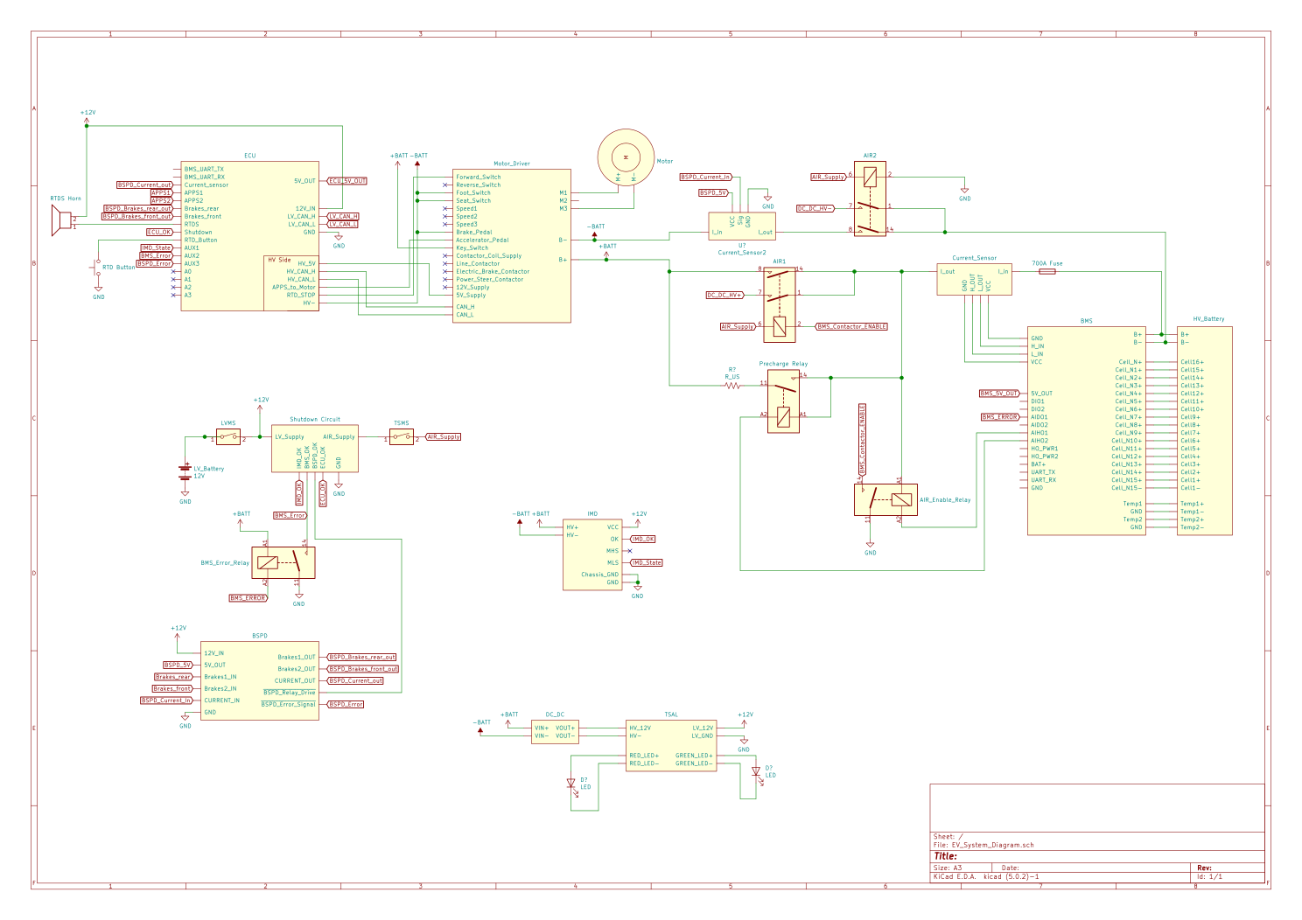

|  |  |
| --- | --- |
| Maximum Tractive-system voltage: | 67.2VDC |
| Nominal Tractive-system voltage: | 57.6VDC |
| Control-system voltage: | 12VDC |
| Accumulator configuration: | 40p16s |
| Total Accumulator capacity: | 100Ah, 5.76KWh |
| Motor type: | DC brushed motor |
| Number of motors: | Total 2, centralized |
| Maximum combined motor power in kW | 32 KW |

*Table 1.1 General parameters*

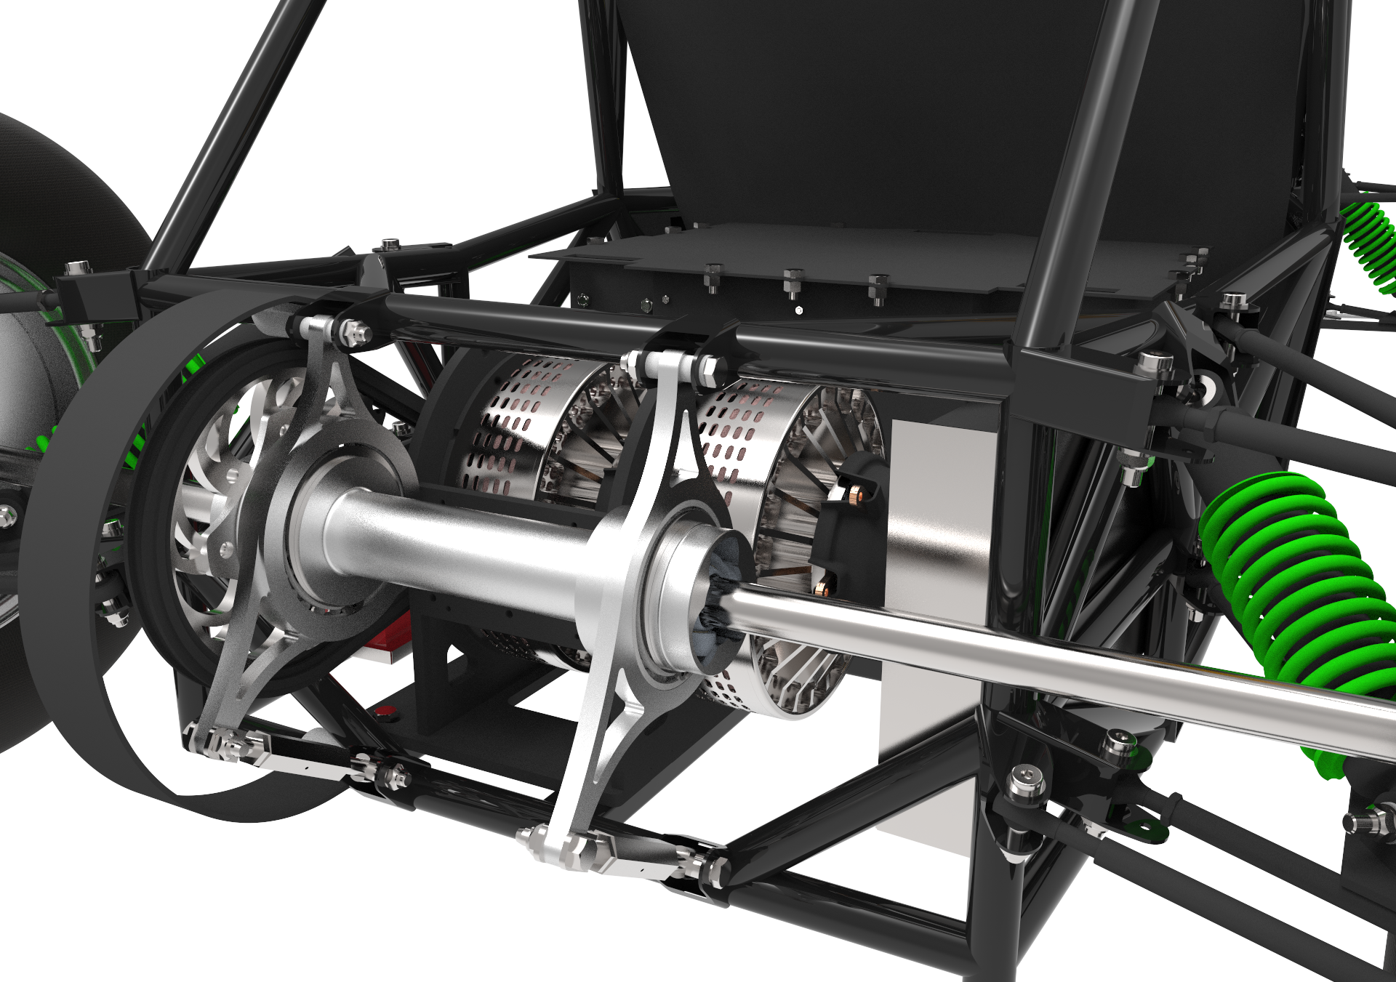

# **Electrical Systems**

## **Shutdown Circuit**

### **Description/concept**

The shutdown circuit is a series of switches, relays and interlocks connected in series with AIRs Coils, the relays act as the power stage for the shutdown circuits, which means that whenever an error is present the supply to the AIR coils is disconnected and the AIR opens.

Figure 2.1 Shutdown circuit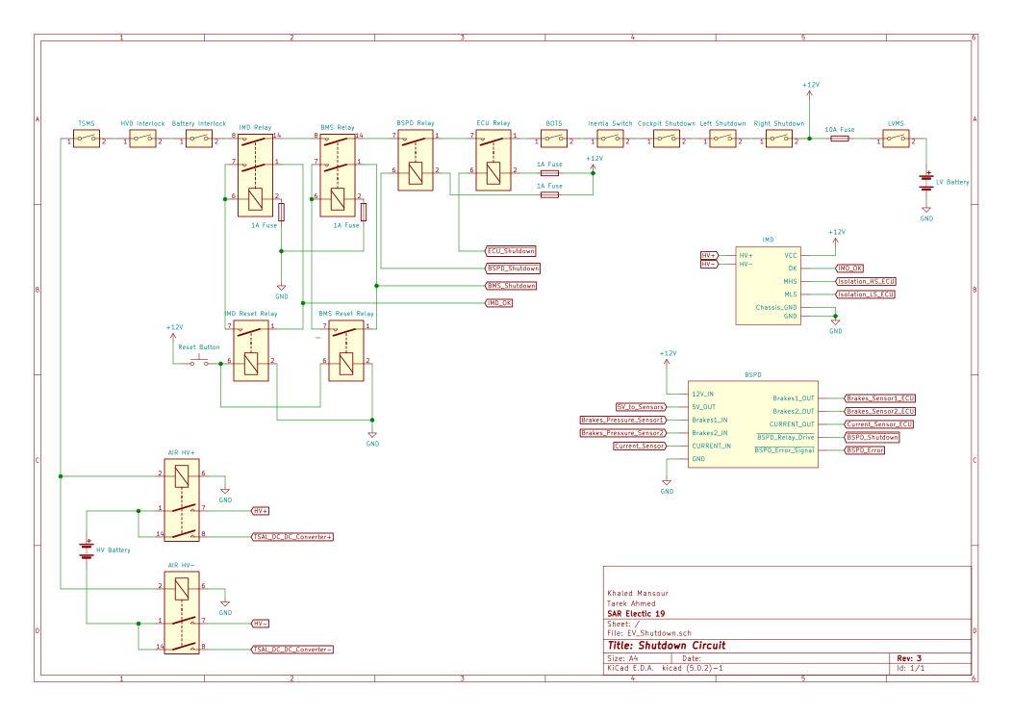

**Low voltage master switch:** a single pole single throw switch that is responsible for powering the shutdown circuit

**Insulation Monitoring Device relay:** when the insulation resistance drops below a set point 500 ohm/volt the IMD opens the shutdown circuit via the relay

**Battery Management System relay:** the BMS will open the shutdown circuit via a relay whenever a failure is detected in the accumulator

**Braking System Plausibility Device relay:** the BSPD will open the shutdown circuit when hard braking occurs whilst more than 5kW of power is delivered to the motor

**Electric Control Unit relay:** the ECU will open the shutdown circuit when a failure is detected by the ECU.

**Brake Over Travel Switch:** a single pole single throw switch that opens the shutdown circuit when the pedal over travel its set point

**Inertia switch:** a single pole double throw switch that opens the shutdown circuit when an impact occurs.

**Shutdown buttons:** three normally closed shutdown buttons one on each side of the vehicle and one in the cockpit each opens the shutdown circuit whenever pressed

**HVD Interlock:** The HVD’s interlock acts as a switch that is closed when the HVD is attached.

**Battery Interlock:** The battery’s connector interlock, acts as a switch that is closed when the battery is connected.

|  |  |
| --- | --- |
| Part | Function |
| Main Switch (for control and tractive-system; CSMS, TSMS) | SPST switch, Normally open |
| Brake over travel switch (BOTS) | SPST switch, Normally closed |
| Shutdown buttons (SDB) | SPST switch, Normally closed |
| Insulation Monitoring Device (IMD) | SPST relay, Normally open |
| Battery Management System (BMS) | SPST relay, Normally open |
| Inertia Switch | SPST switch, Normally closed |
| HVD and Accumulator Interlocks | Closed when HVD and Accumulator are connected |
| Brake System Plausibility Device | SPST relay, Normally open |

*Table 2.1 List of switches in the shutdown circuit*

### **Wiring / additional circuitry**

No extra circuitry is used

|  |  |
| --- | --- |
| Total Number of AIRs: | 2 |
| Current per AIR: | 1A |
| Additional parts consumption within the shutdown circuit: | 1.2A |
| Total current: | 3.2A |
| Cross sectional area of the wiring used: | 0.205 mm² |

*Table 2.2 Wiring – Shutdown circuit*

### **Position in car**

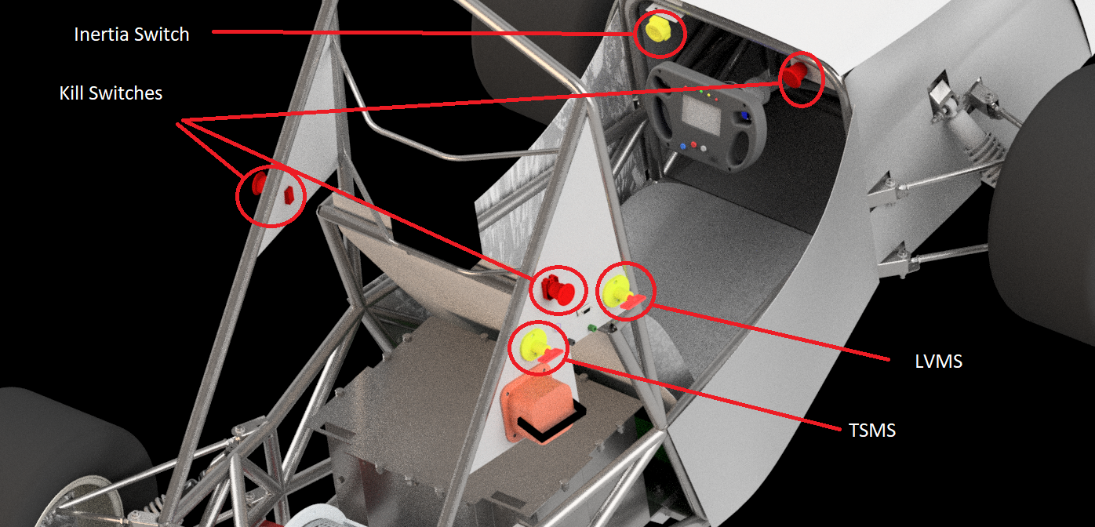

## **IMD**

### **Description**

We are using Bender’s Isometer IR155-3203 with its mounting and connections kit as our main IMD.

Isometer IR155-3203 has 3 outputs for indicating the isolation resistance between HV and LV, the OK output is a digital output that is high when the resistance is higher than the set point and goes low when the resistance goes below the set point. the other two complementary outputs are PWM signals with frequency indicating the current isolation resistance, the pull down output is fed to the ECU to monitor the resistance as an extra safety feature.

|  |  |
| --- | --- |
| Supply voltage range: | 10..36VDC |
| Supply voltage | 12VDC |
| Environmental temperature range: | -40..105°C |
| Self Test interval: | Always at startup, then every 5 minutes |
| High voltage range: | DC 0..1000V |
| Set response value: | 35kΩ (500Ω/Volt) |
| Max. operation current: | 500mA |
| Approximate time to shut down at 50% of the response value: | 15s |

*Table 2.3 Parameters of the IMD*

### **Wiring/cables/connectors/**

The IMD comes with it’s own connector and wiring harness which we connect to the LV batteries 12V and a welded low impedance connection on the grounded chassis and to the HV Batteries positive and negative connection on the AIRs lugs.

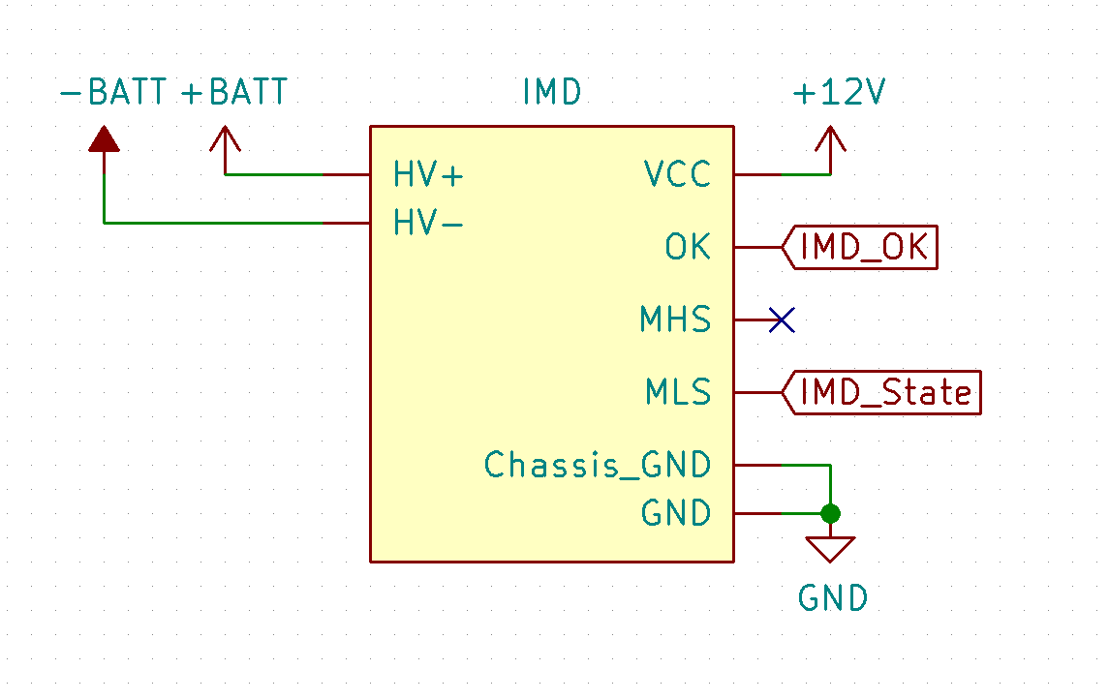

### **Position in car**

The IMD will be attached in a box inside the accumulator pack

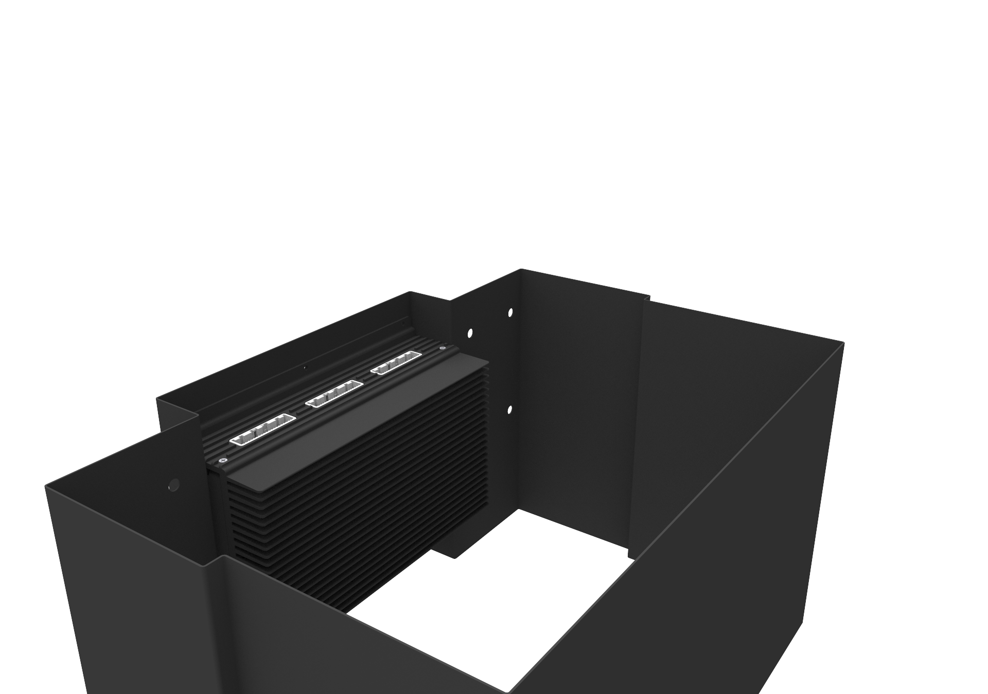

## **Inertia Switch**

### **Description (type, operation parameters)**

The sensor we used is “First Technology’s 360° Resettable Crash Sensor” which is a SPST manually resettable switch that opens the shutdown circuit in case of an impact hence opening the AIRs.

|  |  |
| --- | --- |
| Inertia Switch type: | First Technology’s 360° Resettable Crash Sensor |
| Supply voltage range: | 10..36VDC |
| Supply voltage: | 12VDC |
| Environmental temperature range: | -40..105°C |
| Max. operation current: | 10A |
| Trigger characteristics: | 6g for 40ms / 15g for 10ms |

*Table 2.4 Parameters of the Inertia Switch*

### **Wiring/cables/connectors/**

The switch comes with its own connector with 15 cm wires terminated with shrouded 5mm male terminals which are connected in series with the rest of the shutdown circuit shown in figure 2.1

### **Position in car**

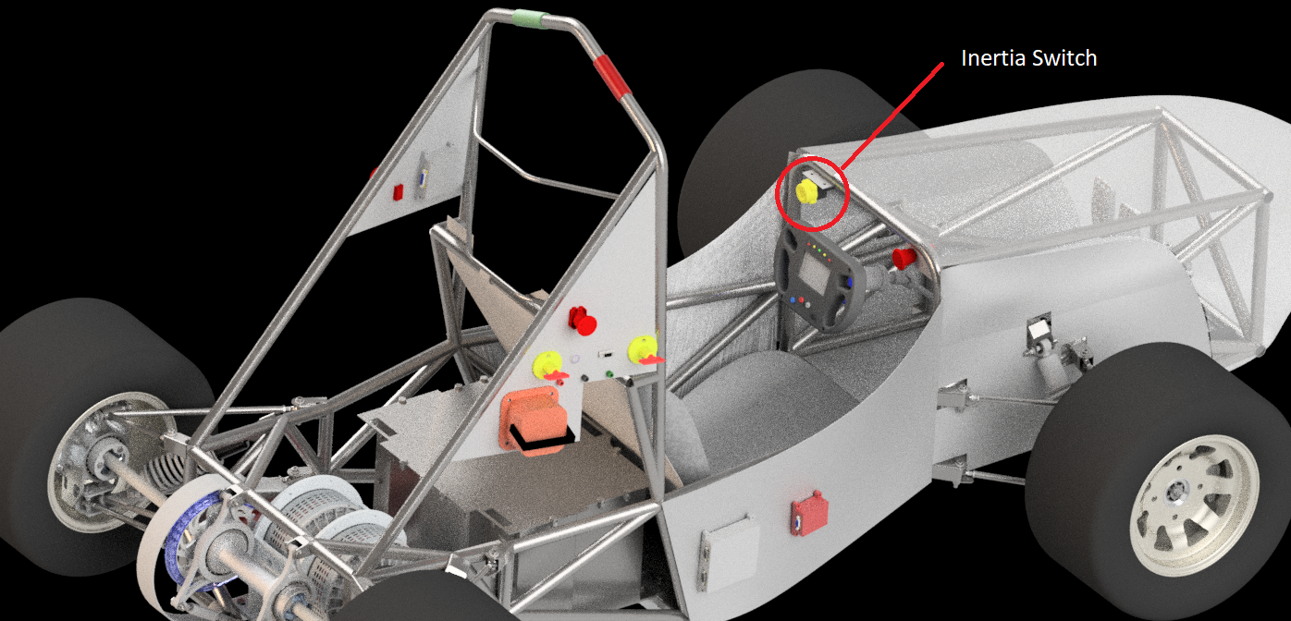

## **Brake System Plausibility Device**

## **Description/additional circuitry**

The BSPD monitors the brake pressure on the front and rear sides and the DC current returning to the battery (HV- side) and whenever either of the brakes sensors measures a pressure higher than 15 bar (2.17V) while the battery current is higher than 87A (0.62V) the shutdown circuit is opened.

These sensors outputs are passed through a RC circuit to filter the signals generate a delay then the comparators compare the voltages to fixed set values, and a logic circuit consisting of AND and OR gates checks for the conditions described above, and finally another RC circuit and a comparator generate a delay to make sure the fault persists for more than 500ms the output then drives a transistor that is used to drive the shutdown circuit relay.

|  |  |
| --- | --- |
| Brake sensor used: | Akozon G1/4" Pressure Transducer Sensor |
| Torque encoder used: | not used with BSPD |
| DC Current measurement used: | DC2T series dismountable hall effect current Sensor |
| Supply voltages: | 5V |
| Maximum supply currents: | 20mA |
| Operating temperature: | -20..180 °C |
| Output used to control AIRs: | Open a relay |

*Table 2.5 Parameters of the Brake System Plausibility Device*

## **Wiring**

*Figure 2. BSPD schematics*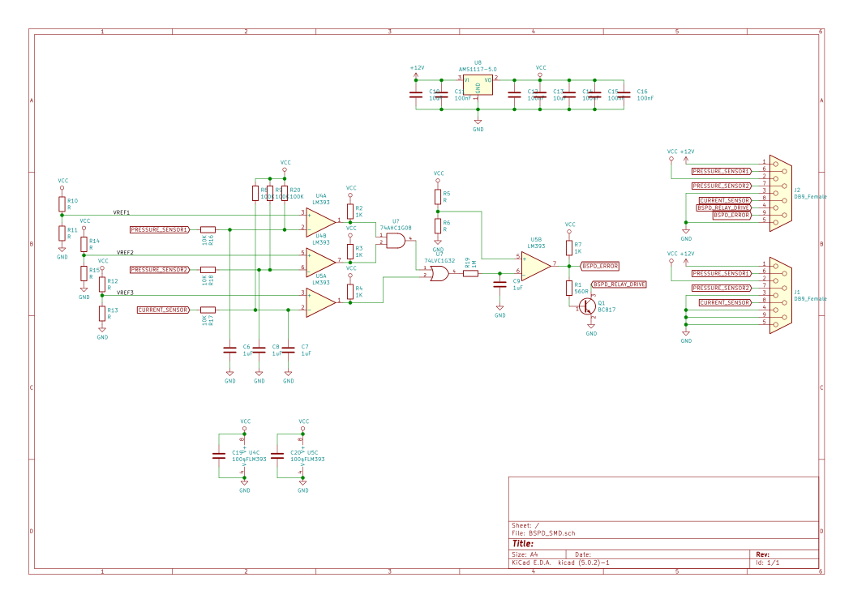

## **Position in car/mechanical fastening/mechanical connection**

The BSPD PCB is fixed inside a 3D printed APS box that is fixed at the rear of the car using M4 bolts and nuts.

### **Wiring/cables/connectors/**

The BSPD circuit connects directly to the brakes sensors and current sensor, it also generates their 5V supply through a DB9 connector.

Shielded cables with 3 internal wires (5V, signal, GND) and waterproof connectors are used to connect the DB9 connector to the sensors.

24AWG wires are used to connect the 12V supply and ground to the BSPD’s input DB9.

Another DB9 is used to pass on the sensors signals and the BSPD output to the rest of the car, one output is the collector of the transistor that’s used to drive the shutdown relay.

### **Position in car**

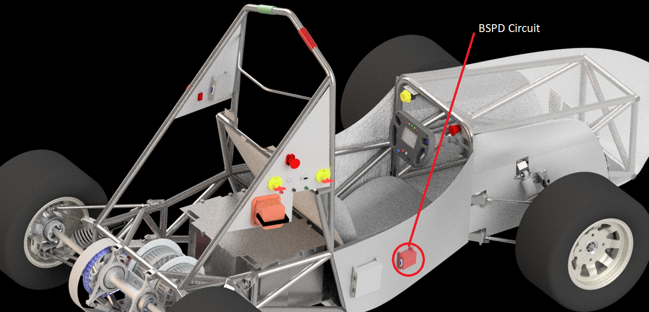

### **Testing Method**

Three potentiometers will be used as voltage dividers and connected in place of the sensors and their values will be changed to emulate the different BSPD conditions, a voltmeter will be used to monitor the potentiometer values.

The BSPD conditions are:

Either or both of the brakes sensors > 2.17V and power > 5 kW

Neither of the brakes sensor > 2.17V and power > 5 kW

Either or both of the brakes sensors > 2.17V and power < 5 kW

Neither of the brakes sensor > 2.17V and power < 5 kW

## **Reset / Latching for IMD and BMS**

### **Description/circuitry**

A relay is used to latch the 2 relays of the BMS and the IMD are Double pole single throw relay with the AIR supply wired through one pole and the relay coil current is routed through the other pole, so when the relay opens it can’t close again until the coil current is passed externally using a relay which is controlled by the reset button.

### **Wiring/cables/connectors**

The relays are plugged in a relay seat and are connected using shrouded male and female copper terminals.

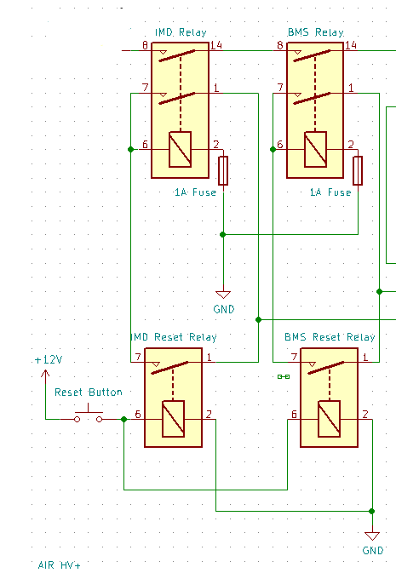

### **Position in car**

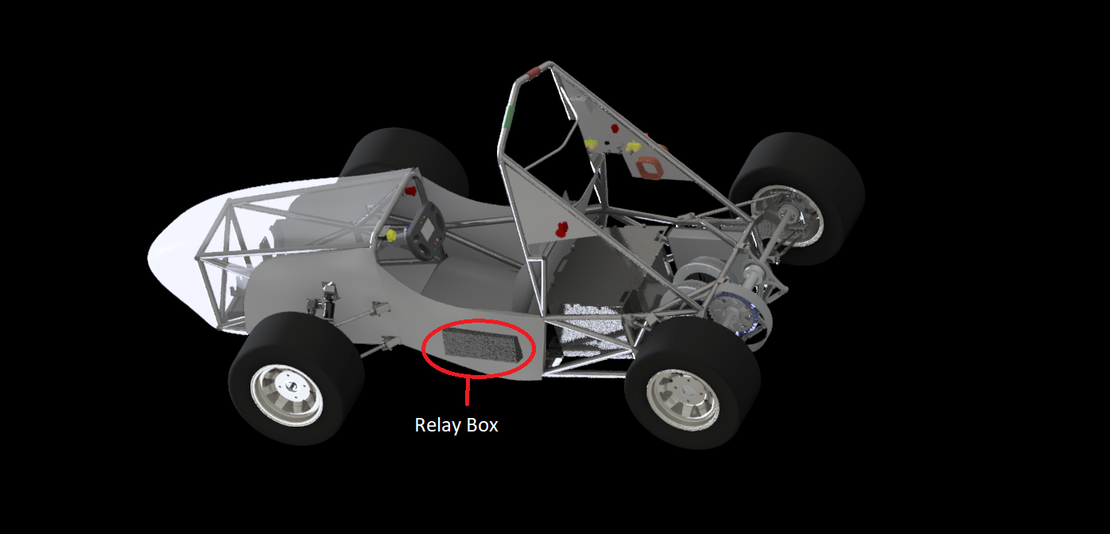

## **Shutdown System Interlocks**

### **Description/circuitry**

The interlocks are an auxiliary connection terminals in both the HVD and the accumulator connector, when the connectors are attached properly the interlocks are closed and the AIRs can be turned on, when the HVD or battery connector is removed the shutdown circuit is open and the AIRs cannot be closed.

### **Wiring/cables/connectors**

The HVD interlock connector is a circular terminal/lug which is attached to the HVD with bolts and nuts and the other end is male copper terminals which are connected with the shutdown circuit

The battery connector interlock has 2 flying leads which have male copper terminals which are connected with the shutdown circuit.

24 AWG wires are used for both.

### **Position in car**

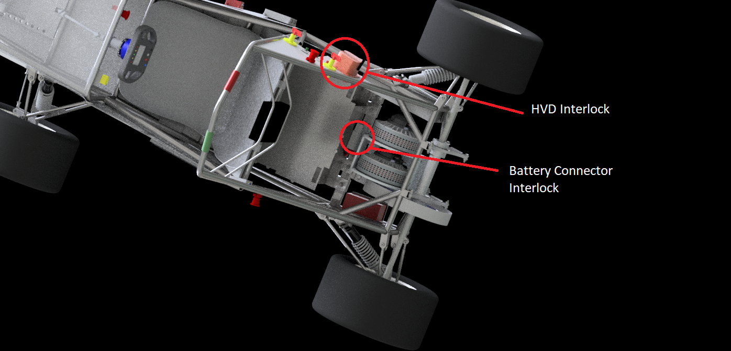

## **Tractive system active light**

### **Description/circuitry**

TSAL consists of separate red and green high brightness LEDs strips with plastic housing, the green LEDs are powered from the LV battery, and the red LED is powered from a DC-DC converter that is part of the TS and the switching frequency of the red LED is done by using a 555 timer monostable circuit, and optocoupler is used to switch off the green LED when the TS is turned on.

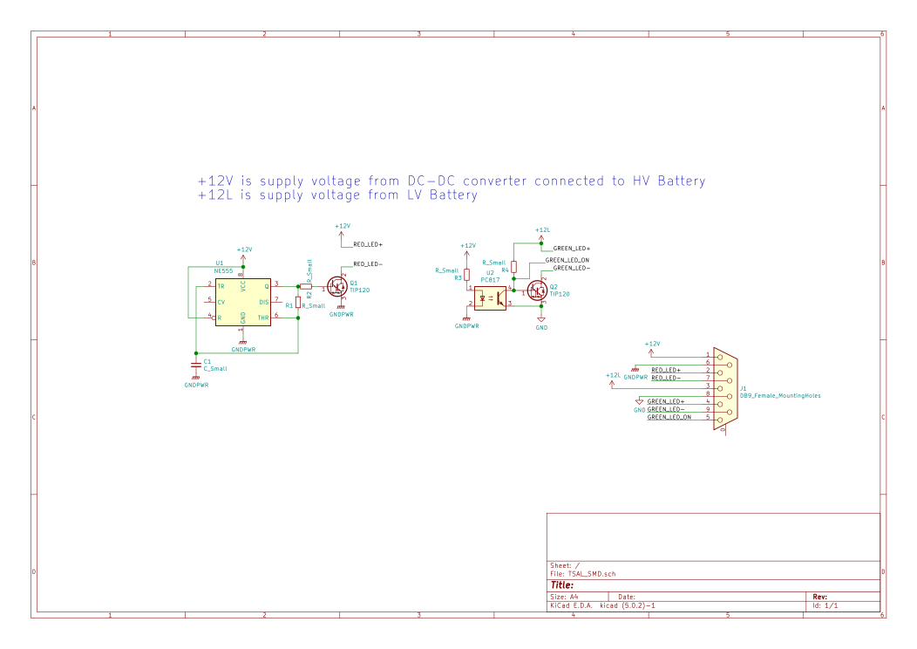

|  |  |  |
| --- | --- | --- |
|  | Red | Green |
| Supply voltage: | 12VDC | 12VDC |
| Max. operational current: | 500mA | 500mA |
| Lamp type | LED | LED |
| Power consumption: | max :6 W  avg : 3 W | 6 W |
| Brightness | 150 Lumen | 150 Lumen |
| Frequency: | 3Hz | continuous |
| Size (length x height x width): | 75mm x 90mm x 4mm | 75mm x 90mm x 4mm |

*Table 2.6 Parameters of the TSAL*

### **Wiring/cables/connectors**

There is a single DB9 connector that connects the DC-DC converter, LEDs, LV supply and ground to the TSAL PCB.

### **Position in car**

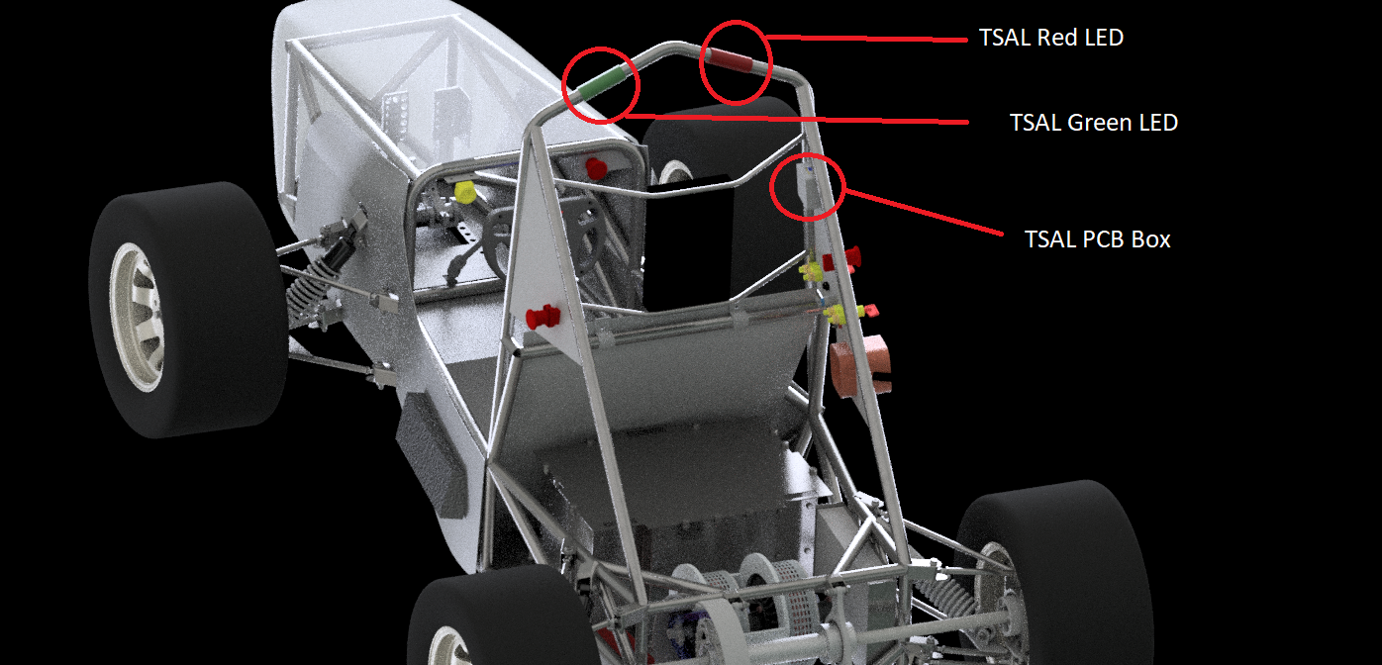

## **Measurement points**

### **Description**

Shrouded banana jacks red for HV+, black for HV-, green for chassis ground

### **Wiring, connectors, cables**

The HV+ and HV- are connected directly to the battery terminals on the motor controller, and the chassis ground is connected to a welded low impedance point in the chassis (which is grounded).

spade lugs are used on the banana jacks and circular terminals (lugs) are used on the other end.

### **Position in car**

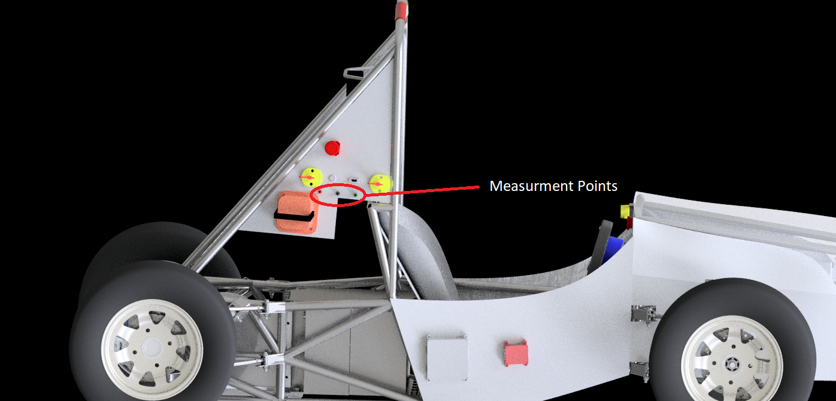

## **Pre-Charge circuitry**

### **Description**

When initially connecting a battery to a load with capacitive input, there is an inrush of current as the load capacitance is charged up to the battery voltage. With large batteries and powerful loads , the inrush current can be very high.

A precharge circuit limits that inrush current, without limiting the operating current.

At first the pre-charge relay closes the circuit so that the inrush current will be damped by the pre-charge resistor. And after the inrush current pases the pre-charge relay will open the circuit and the +ve AIR will close the circuit so that the normal current passes to the load.

### **Wiring, cables, current calculations, connectors**

The wiring consists of three wires in parallel.

The first is connected from the +ve terminal of the battery to an AIR to the load.

The second is connected from the +ve terminal of the battery to the pre-charge relay in series with the pre-charge resistor to the load.

The third is connected from the -ve terminal of the battery to an AIR to the load.

* Give a plot “Percentage of Maximum Voltage” vs. time

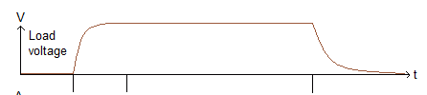

* Give a plot Current vs. time

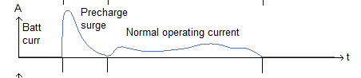

* For each plot, give the basic formula describing the plots

Vs - R*i(t) - Vc(t) = 0

i = Vs/R

Tau = RC

Vc = Vs*[1-e^(-t/RC)]

* Where:
* Vc is the voltage across the capacitor
* Vs is the supply voltage
* t is the elapsed time since the application of the supply voltage
* RC is the time constant of the RC charging circuit
* 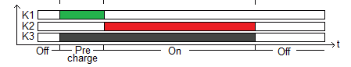

Additionally fill out the tables:

|  |  |
| --- | --- |
| Resistor Type: | Power Resistor |
| Resistance: | 10KΩ |
| Continuous power rating: | 20W |
| Overload power rating: | 200W for 5sec |
| Voltage rating: | 550V |
| Cross-sectional area of the wire used: | 0.823 mm² |

*Table 2.7 General data of the pre-charge resistor*

|  |  |
| --- | --- |
| Relay Type: | RS Pro |
| Contact arrangment: | SPDT NO |
| Continuous DC current: | 12A |
| Voltage rating: | 60VDC @ 6A |
| Cross-sectional area of the wire used: | 0.823 mm² |

*Table 2.8 General data of the pre-charge relay*

### **Position in car**



The precharge relay will be Positioned inside the accumulator pack in the shown box.

## **Discharge circuitry**

### **Description**

### **Wiring, cables, current calculations, connectors**

Discharge resistors are built in our motor controller so no external discharge circuitry is needed

|  |  |
| --- | --- |
| Resistor Type: | No data is available |
| Resistance: | No data is available |
| Continuous power rating: | No data is available |
| Overload power rating: | No data is available |
| Voltage rating: | No data is available |
| Maximum expected current: | No data is available |
| Average current: | No data is available |
| Cross-sectional area of the wire used: | No wiring is used |

*Table 2.9 General data of the discharge circuit*

### **Position in car**

Built into the motor controller.

## **HV Disconnect (HVD)**

### **Description**

We are using Amphenol’s MSDXL the 630A version as our HVD, it’s connected between the positive terminal of the accumulator and the motor controller.

It’s operated through a 2 step mechanism a lever to disconnect the interlock which opens the shutdown circuit and closes the AIRs which cuts off the current going through the HVD then the male part of the connector is removed to disconnect the the positive terminal of the battery.

### **Wiring, cables, current calculations, connectors**

The MSD has 2 connection in the form of M6 bolts so double circular lugs with nuts are used to attach the battery wires to the HVD.

### **Position in car**

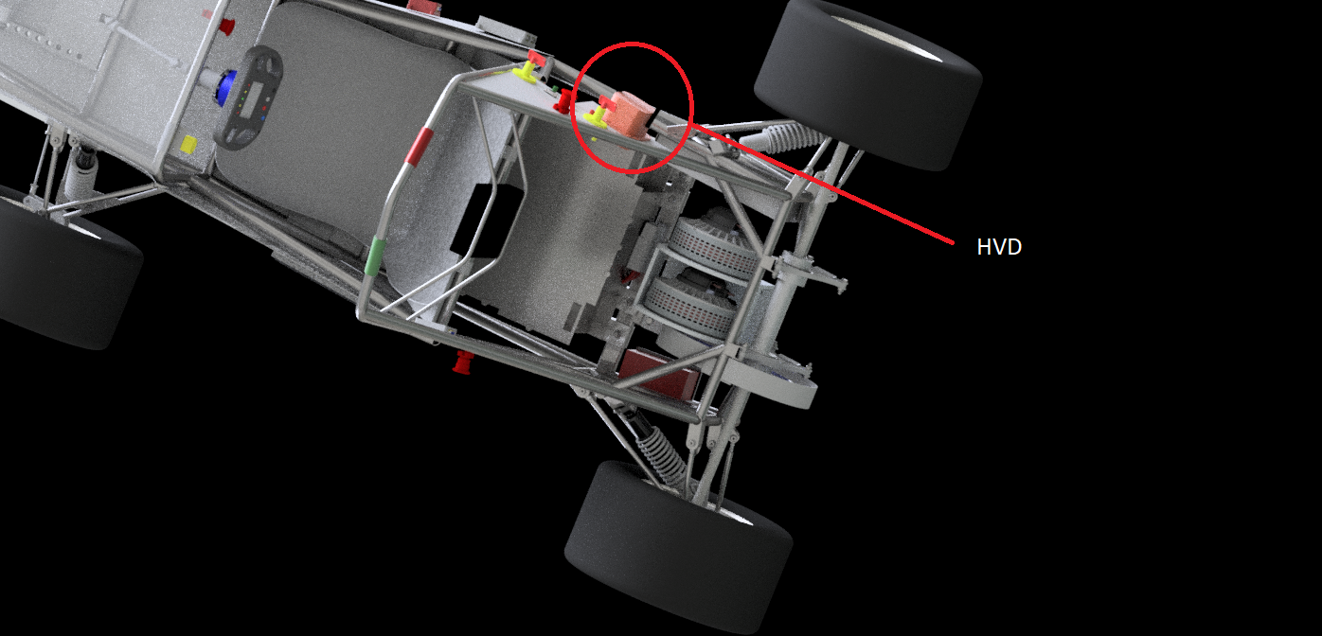

## **Ready-To-Drive-Sound (RTDS)**

### **Description**

The RTDS is triggered by the ECU when the driver pushes the brakes pedal then pushes the ready to drive button which enables the APPS signal to the motor controller and enables the RTD feature in the motor controller, at the same time the RTDS is produced through a 105 dB horn.

### **Wiring, cables, current calculations, connectors**

The horn is driven from the ECU PCB using a power NPN transistor, a shrouded female terminal used to connect to the horn and on the other side is a connection on DB25 connector.

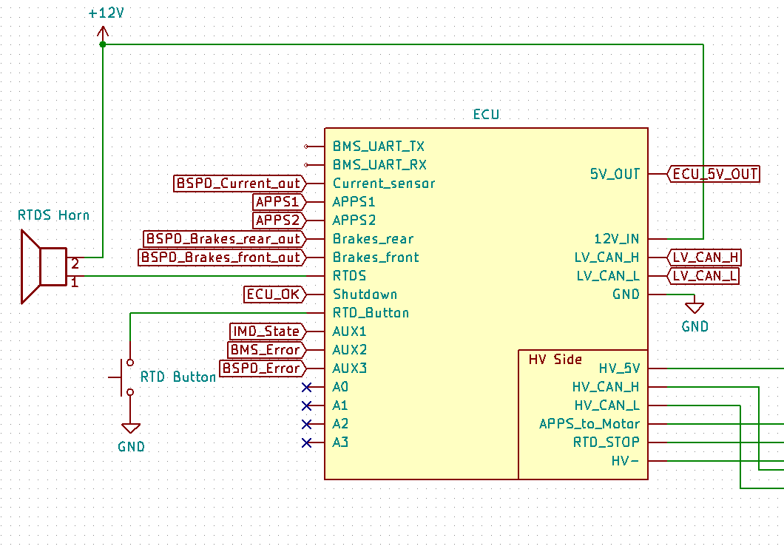

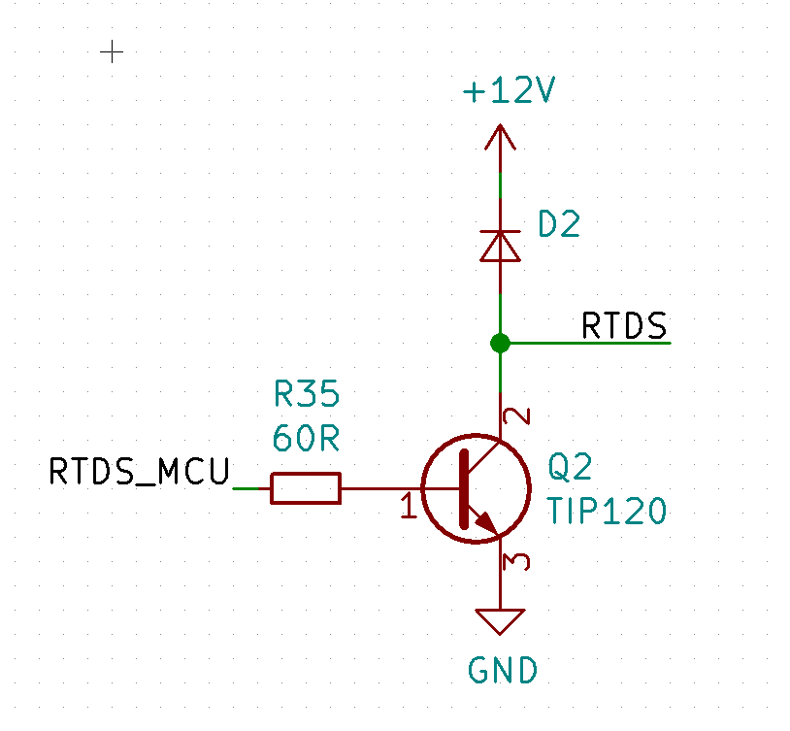

### **Position in car**

The RTDS horn will be fixed inside the Relay box



# **Accumulator**

## **Accumulator pack 1**

### **Overview/description/parameters**

The accumulator pack is designed from steel sheet metal as well as internal steel sheet metal for the internal wall separators between segments. It has Energus blocks as its main building blocks.

Each block is composed of 20 parallel Samsung cells giving a total of 50Ah and 3.6 VDC nominal. It is arranged in a configuration of 2 parallel string of blocks with 16 block in series in each block.

The pack is divided into 4 segments separated by steel wall with Insulation sheets from both sides and all around the blocks.

Each segment has a total of 8 blocks and the segments’ terminals are connected together in series through maintenance plugs connectors. All the blocks are surrounded with sheet metal with a steel strap on top to prevent any movement; the whole blocks are connected through bus bars to minimize unnecessary wiring.

The Accumulator is fixed from 10 different points on the bottom of the battery, each fixation point is bolted to an aluminum bracket that is bolted to a rectangular tube that is welded to the frame. In order to remove the battery from the frame the bolts connecting it will be unfastened and the battery will be easily removed from the back of the frame where we made sure that the pathway of the battery removal remains unobstructed .

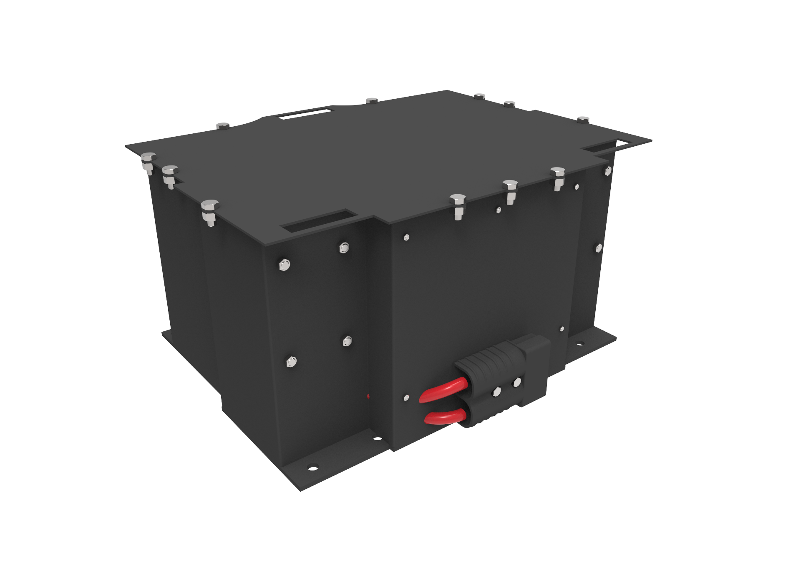

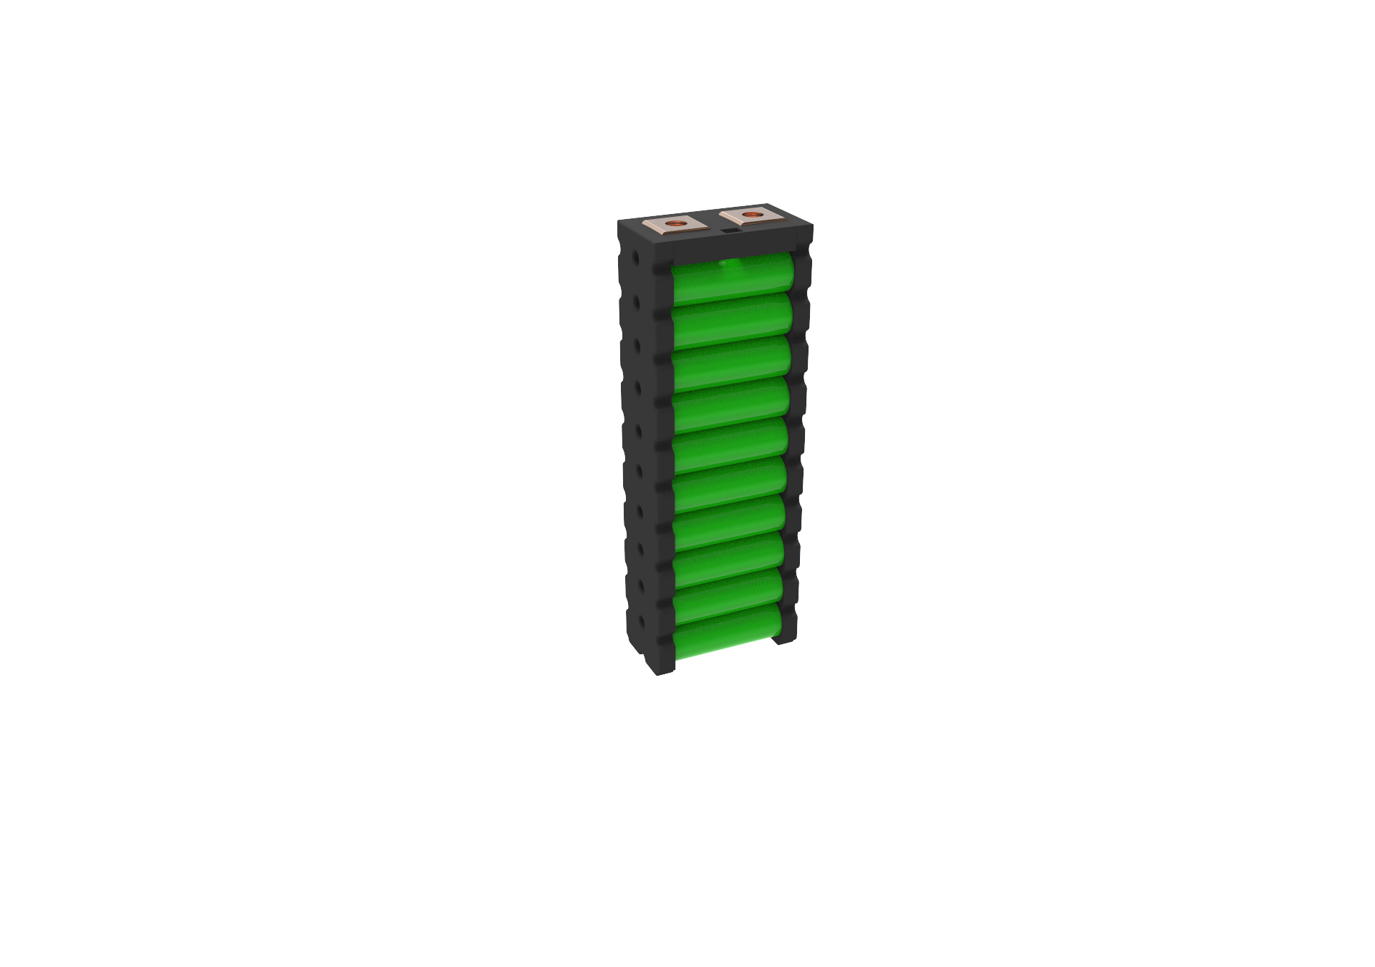

|  |  |
| --- | --- |
| Maximum Voltage: | 67.2VDC |
| Nominal Voltage: | 57.6VDC |
| Minimum Voltage: | 40VDC |
| Maximum output current: | 550A for 10s |
| Maximum nominal current: | 400A |
| Maximum charging current: | 35A |
| Total numbers of cells: | 640 |
| Cell configuration: | 40p16s |
| Total Capacity: | 20.7 MJ |
| Number of cell stacks < 120VDC | 4 Segments, 8 blocks in each, 160 Samsung cells in each |

*Table 3.1 Main accumulator parameters*

### **Cell description**

The Energus blocks are composed of Lithium Ion Samsung INR18650-25R cells

|  |  |
| --- | --- |
| Cell Manufacturer and Type | Energus for the blocks/ Samsung for the cells |
| Cell nominal capacity: | 2.5 Ah |
| Maximum Voltage: | 4.2 V |
| Nominal Voltage: | 3.6V |
| Minimum Voltage: | 2.5V |
| Maximum output current: | 37.5A |
| Maximum nominal output current: | 20A(at 25°C), 60% at 250 cycle |
| Maximum charging current: | 4 A |
| Maximum Cell Temperature (discharging) | 60°C |
| Maximum Cell Temperature (charging) | 45°C |
| Cell chemistry: | Li-ion |

*Table 3.2 Main cell specification*

### **Cell configuration**

There are 32 modules (20 cells each) connected as 2p16s, divided into 4 segments which are connected with each other in series with maintenance plugs.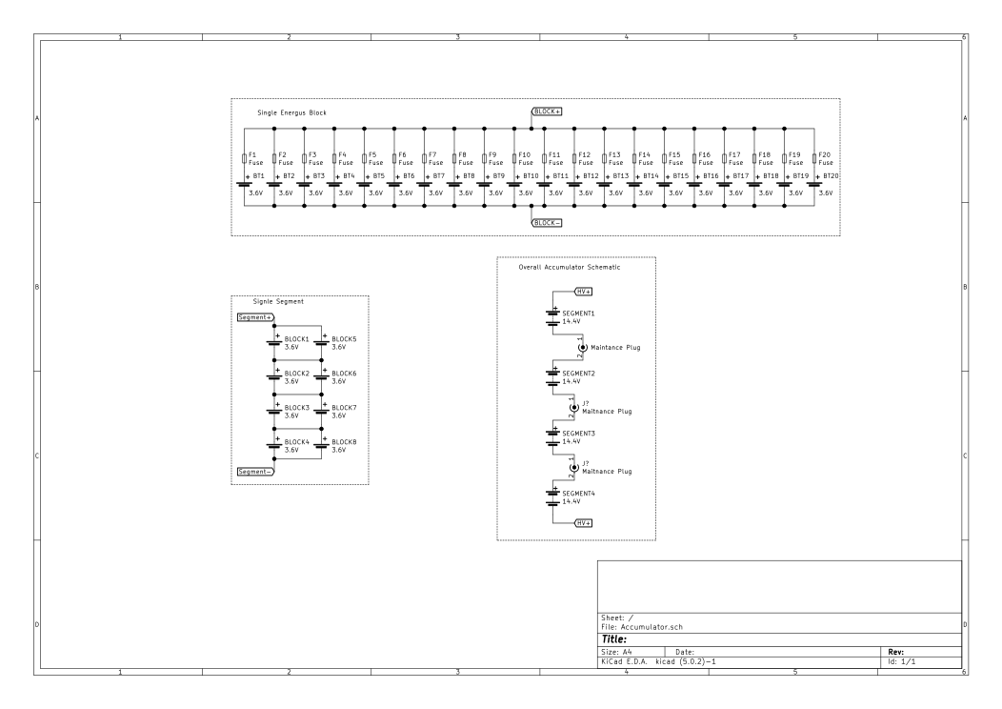

Each segment contains 8 blocks divided in 2 four-blocks’ strings with a total of 160 cells. The Energus blocks are created from UL94-V0 rated fire retardant plastic in addition to containing internal temperature sensors to be connected to the BMS for temperature monitoring.

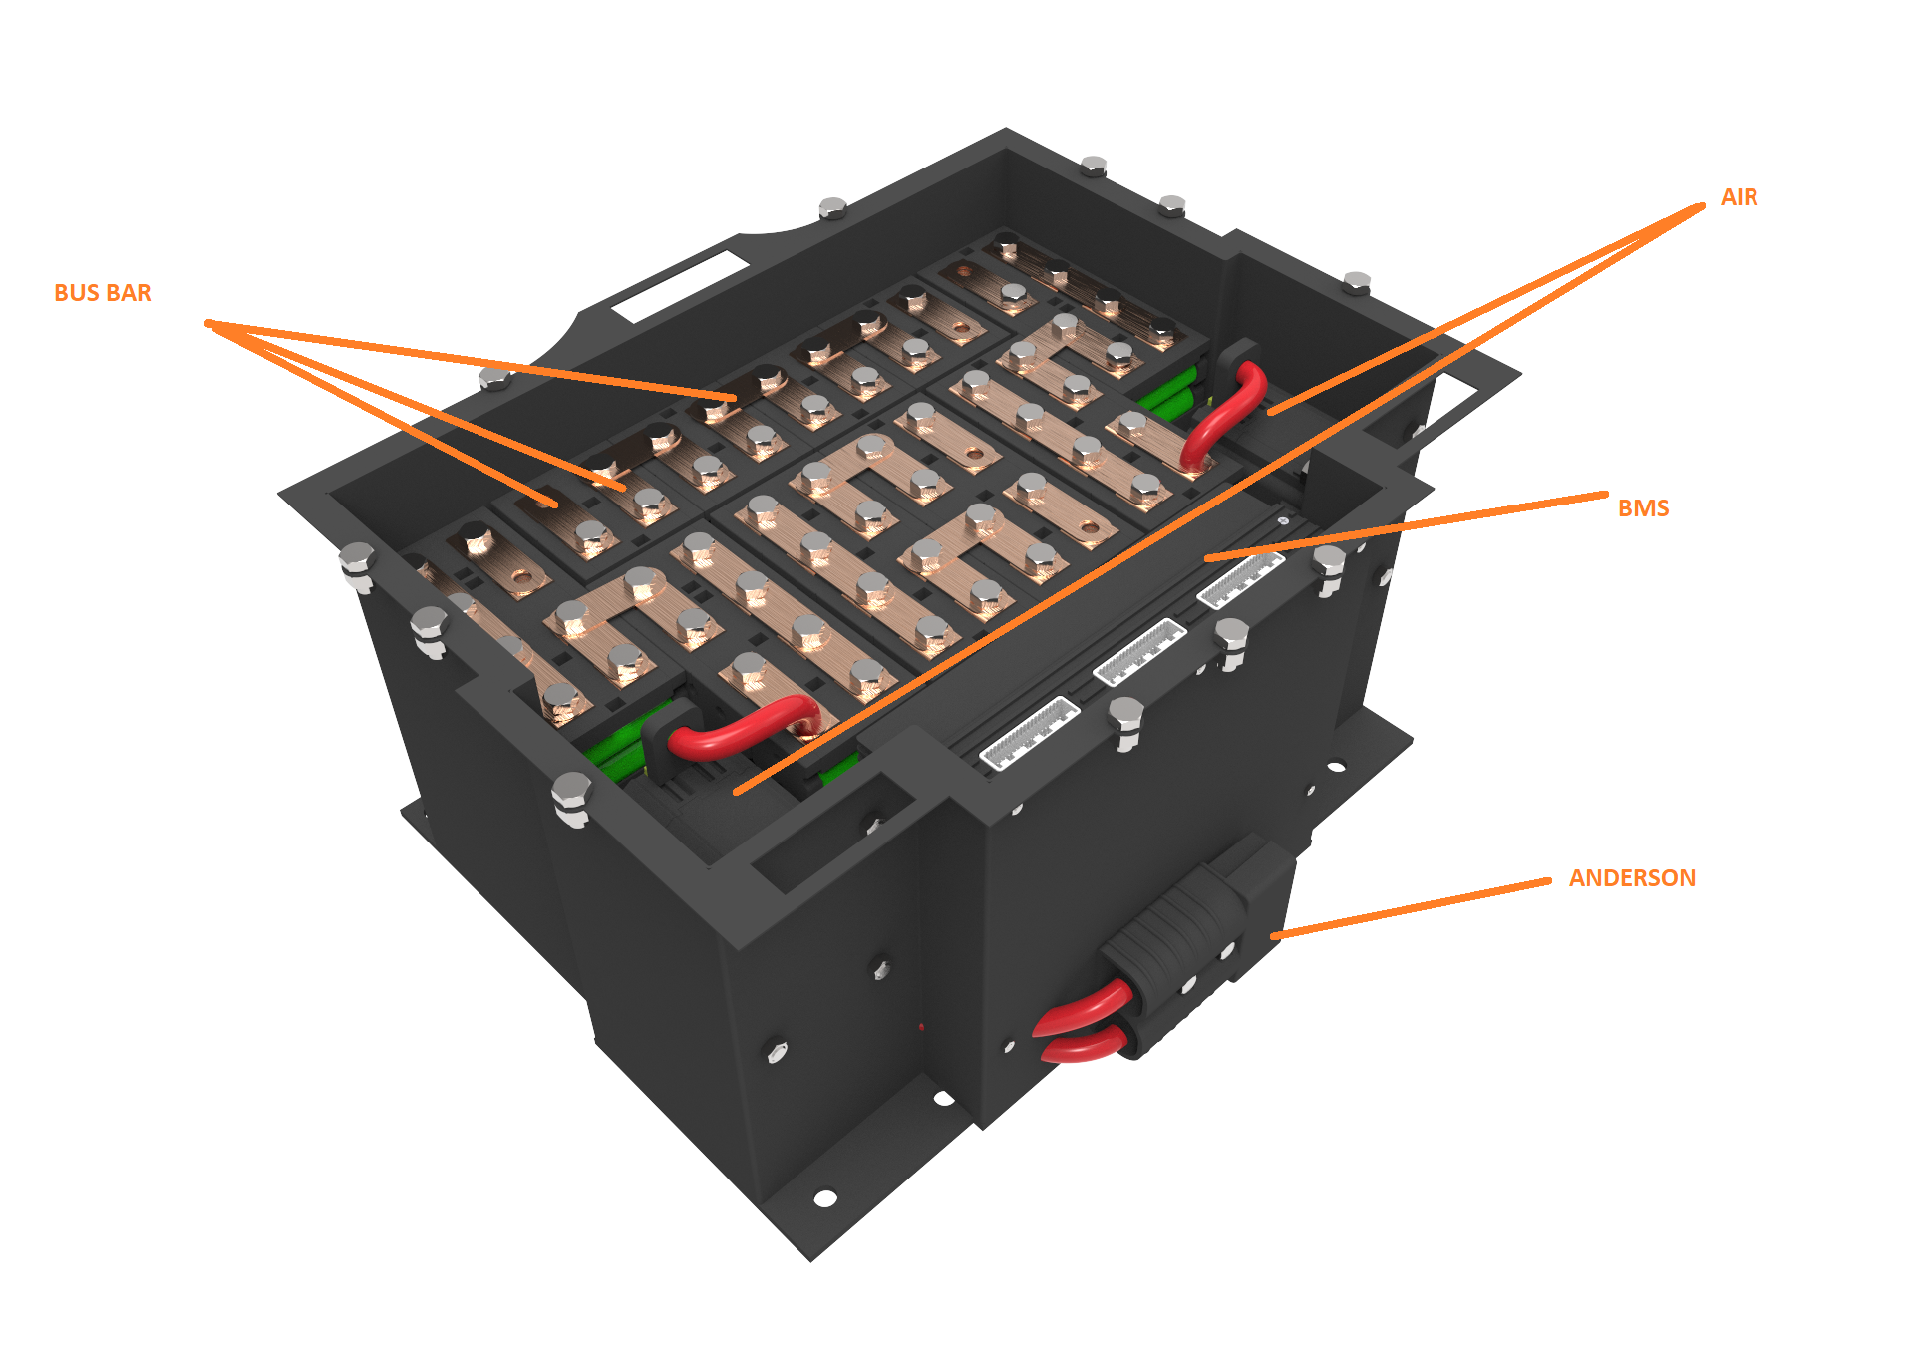

The cells are individually fuse-protected, no parallel fusing is required internally.

Each cell inside the block has 2 fuses connected internally to its terminals. The internal fuse current has a holding current of 360A.

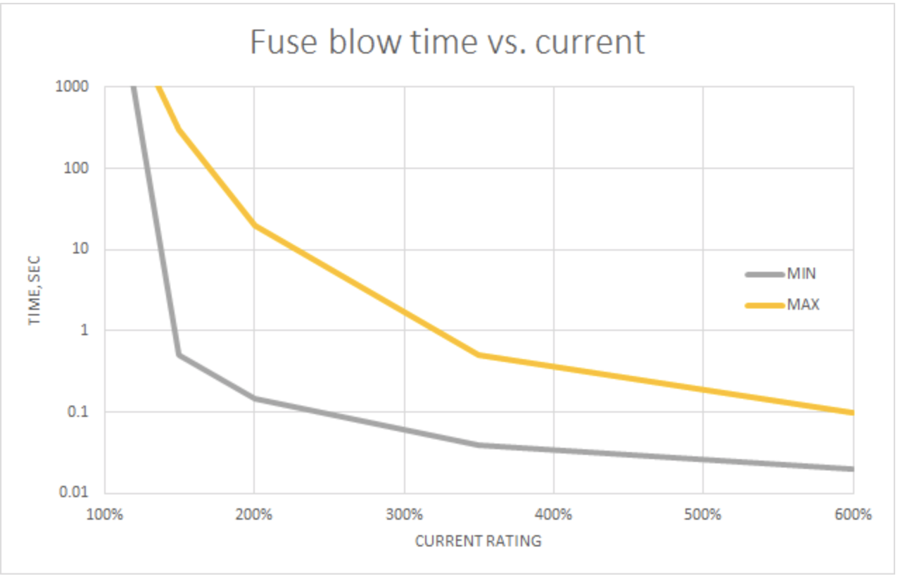

### **Cell temperature monitoring**

Each Energus block contains 10 points temperature sensors which are built in. Each one is in physical contact with negative poles of 2 adjacent cells. Having the same in all the blocks, this means that 100% of the cells will be monitored. Figure shows the sensor’s position inside the blocks.

Analogue signal OR’ing technique allows all 4 sensor signals to be read with two-wire acquisition system: output acts as a hotspot detector and reports only the maximum temperature.

When battery is operating within safe limits, all four sensors report similar temperatures and such measurement accurately represents overall temperature of the module. However, in case of failure event, hot spot is very quickly noticed.

The sensor acts as a Zener diode, its voltage drops depending on temperature.

The sensor is connected to the Energus BMS channels as shown in the below schematic.

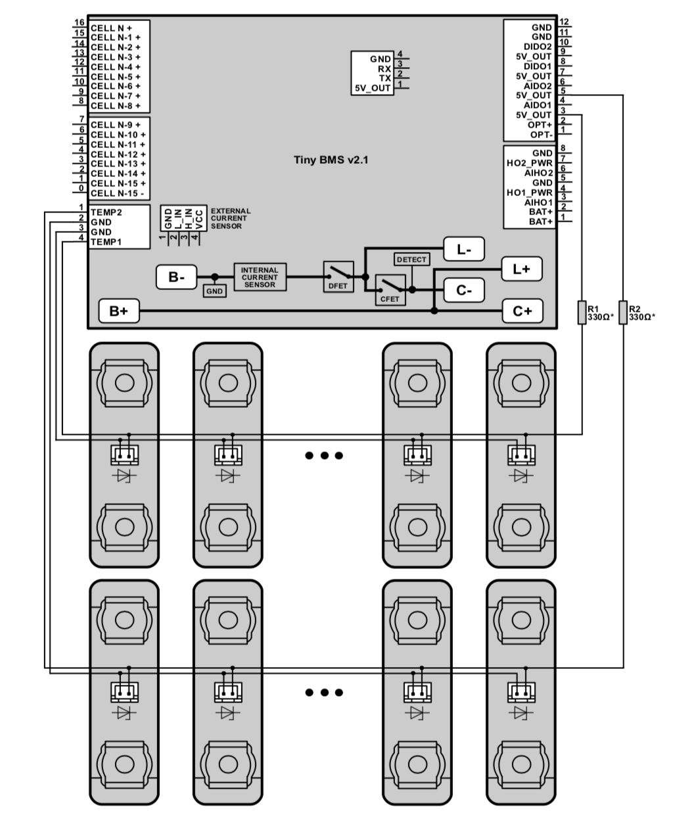

Appendix 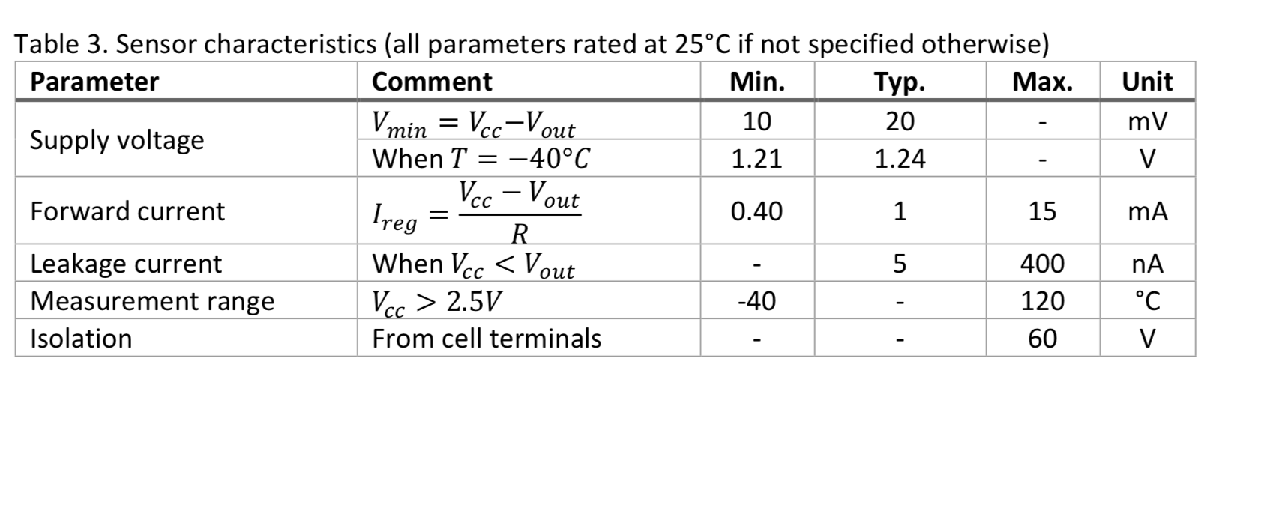

Appendix

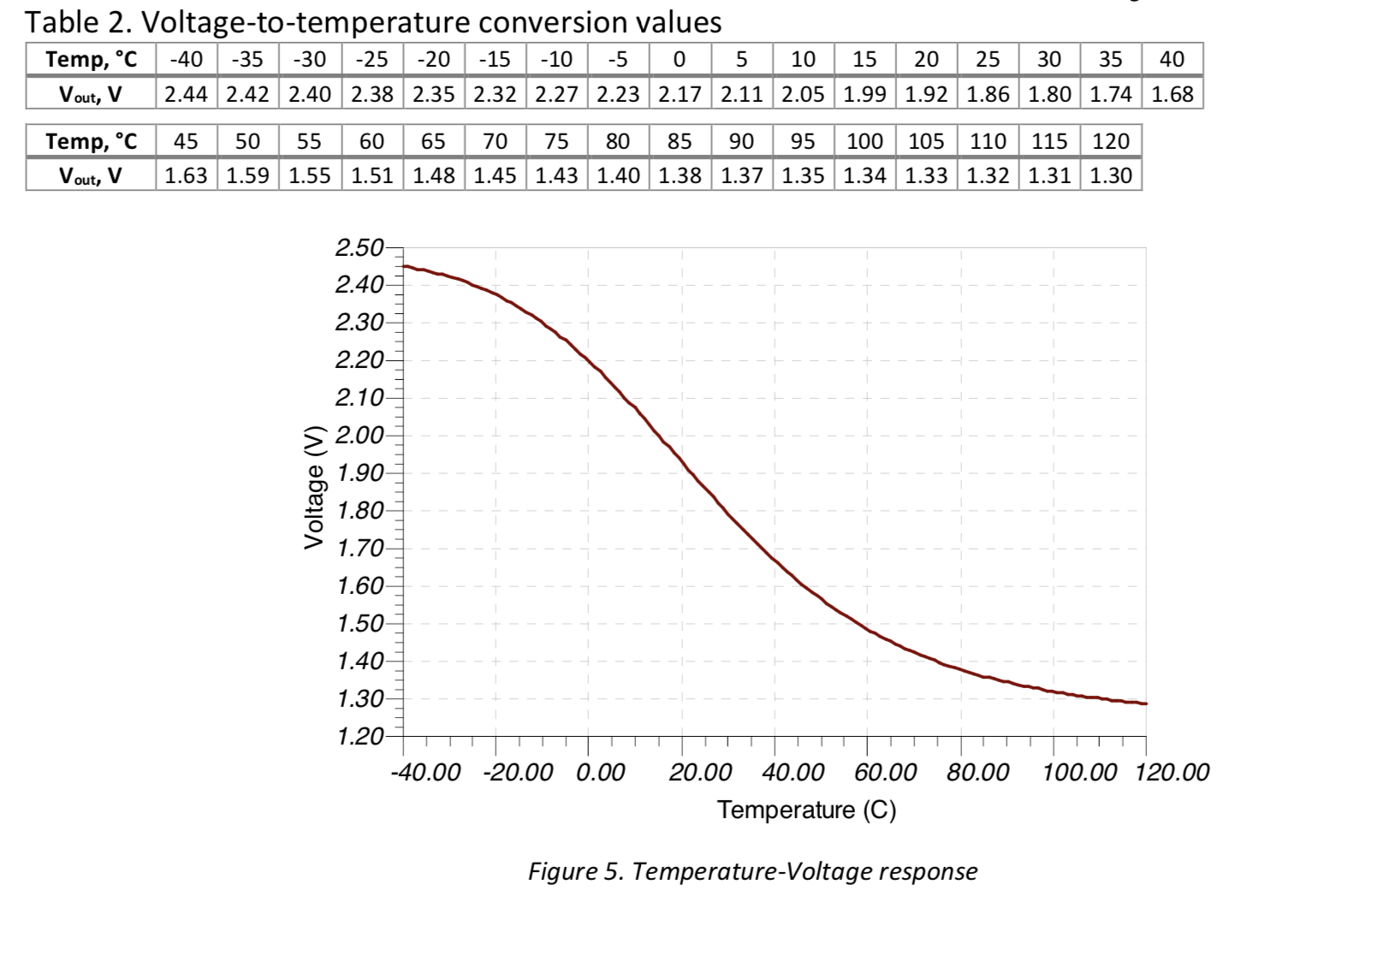

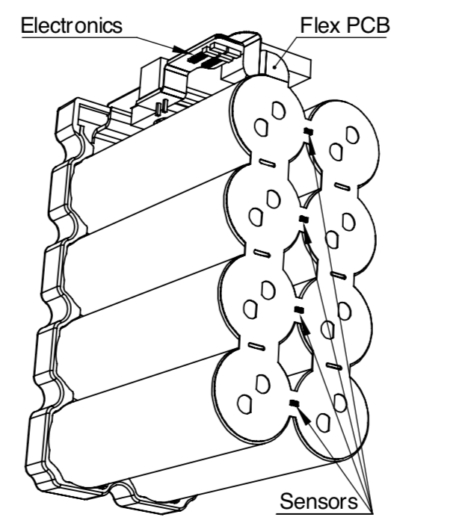

### **Accumulator insulation relays**

Describe the AIRs used and their main operation parameters, use tables, etc.

Additionally fill out the following table:

|  |  |
| --- | --- |
| Relay Type: | GigaVAC GX56 |
| Contact arragment: | SPST |
| Continuous DC current rating: | 800A @ 60V |
| Overload DC current rating: | 3000A for 10 sec |
| Maximum operation voltage: | 800VDC |
| Nominal coil voltage: | 12VDC |
| Normal Load switching: | Make and break up to 300A |
| Maximum Load switching | 10 times at 1500A |

*Table 3.3 Basic AIR data*

### **Fusing**

The used fuse is a bolted tag fuse which will be connected directly to the positive bolt of the battery pack in the tractive system path.

The fuse protects the cable against both overload and short circuit, According to the shown calculations.

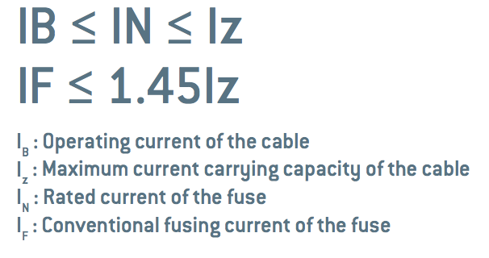

It was also selected to withstand the system’s current and ensure the protection in case of overloading or short circuit.

|  |  |
| --- | --- |
| Fuse type: | Merson C3 bolted tag fuse |
| Continous current rating: | 670A |
| Maximum operating voltage | 240VDC |
| Type of fuse: | bolted tag fuse |
| I2t rating: | 5460000A2s at 240VDC |
| Interrupt Current (maximum current at which the fuse can interrupt the current) | 80KA-RMS |

*Table 3.4 Basic fuse data*

|  |  |
| --- | --- |
| AIRs (Maximum) | 800A (1000A/ 500 second) |
| Batteries(Maximum) | 750A |
| Cables(Nominal) | 500A (Rated is higher than the fuses’s 550A) |
| Motor(Maximum) | 800A |
| Motor controller(Maximum) | 650A |

*Table 3.5 Protected parts by fuse*

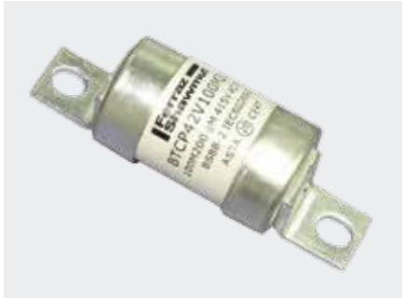

### **Battery management system**

Describe the BMS used including at least the following:

* Sense wiring protection (fusing / fusible link wire used)
* What upper and lower voltage does the BMS react at and how does it react?

The voltages at which this BMS reacts are adjustable. In our case, the BMS will be used to prevent the over-discharging of the cells. This will occur when the voltage of any cell monitored by the BMS falls below 2.5 V. At this point, the BMS will prevent the accumulator from providing any more power. The BMS will also be used when charging the battery to prevent over charging. Because of the CANBUS output on this BMS, it is possible for the BMS to communicate with the charger and prevent it from overcharging. This will occur when the cell voltages within the accumulator approach 4.2 V.

The BMS is provided by Energus, it’s a centralized BMS with no additional cell boards used.

The BMS will react when the temperature reaches 60, it will react by sending a signal to the shutdown circuit’s BMS relay which in turn would open the AIRs.

100% of the battery pack’s cells will be monitored (check this section).

The BMS controls a relay that turn on the supply to a shutdown relay when no error is detected and turns off that supply when an error is detected, the 2 relay system is used to establish galvanic isolation and comply with the shutdown system rules.

The used energus TinyBMS is placed inside a protective casing, fixed inside the battery pack.When it detects any problem like (overcurrent, overvoltage, undervoltage or over temp.) it sends a signal to open the contacts of the AIRs.

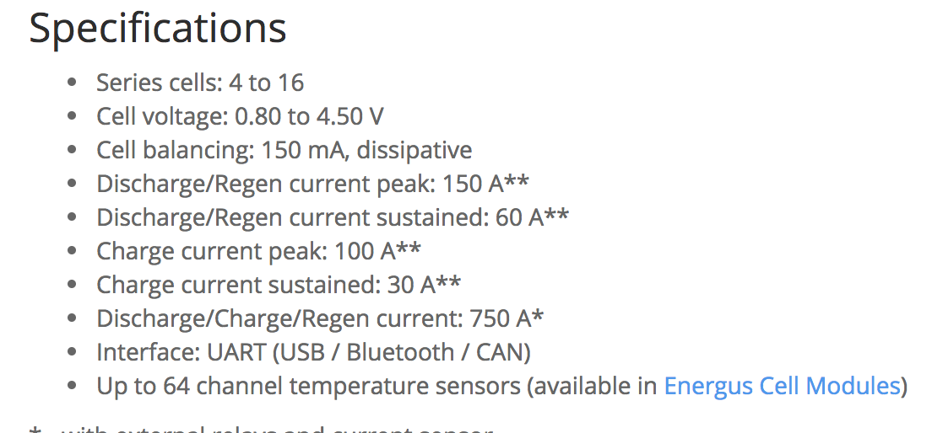

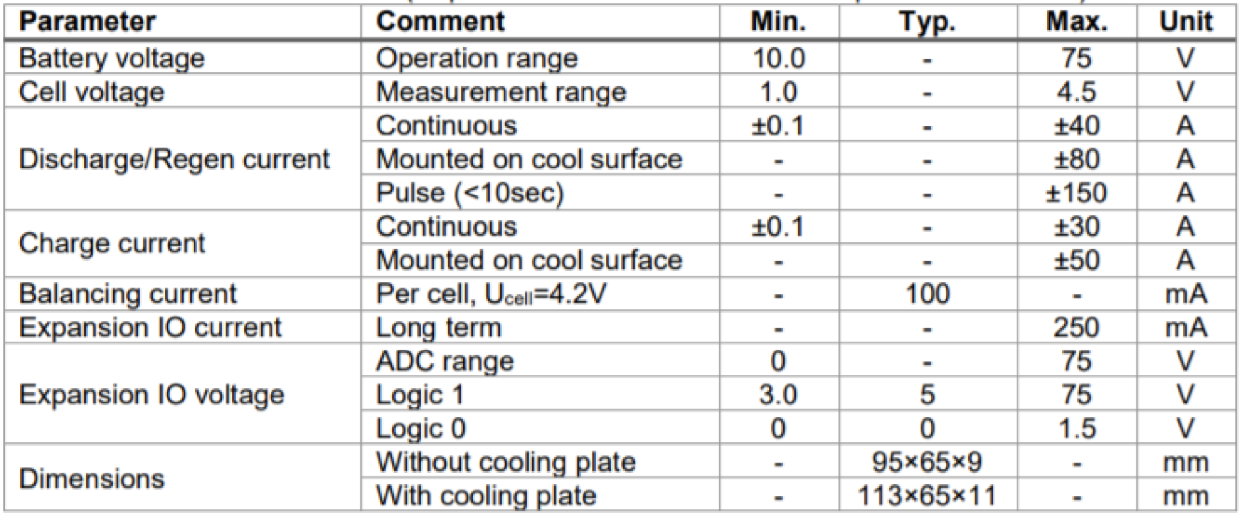

### **Accumulator indicator**

Describe the indicator, show wiring, provide tables with operation etc.

The BMS monitors the accumulator state and voltage and provides it through a uart interface which goes through a uart optical isolator in the ECU

All the BMS readings appears on the dashboard that is fixed on the steering wheel, the readings include

### **Wiring, cables, current calculations, connectors**

Maximum expected current will be 500 ADC because we will limit it using the motor controller, and it’ll last maximum of 10 sec.

The nominal current is 426 ADC and the maximum is 550 ADC.

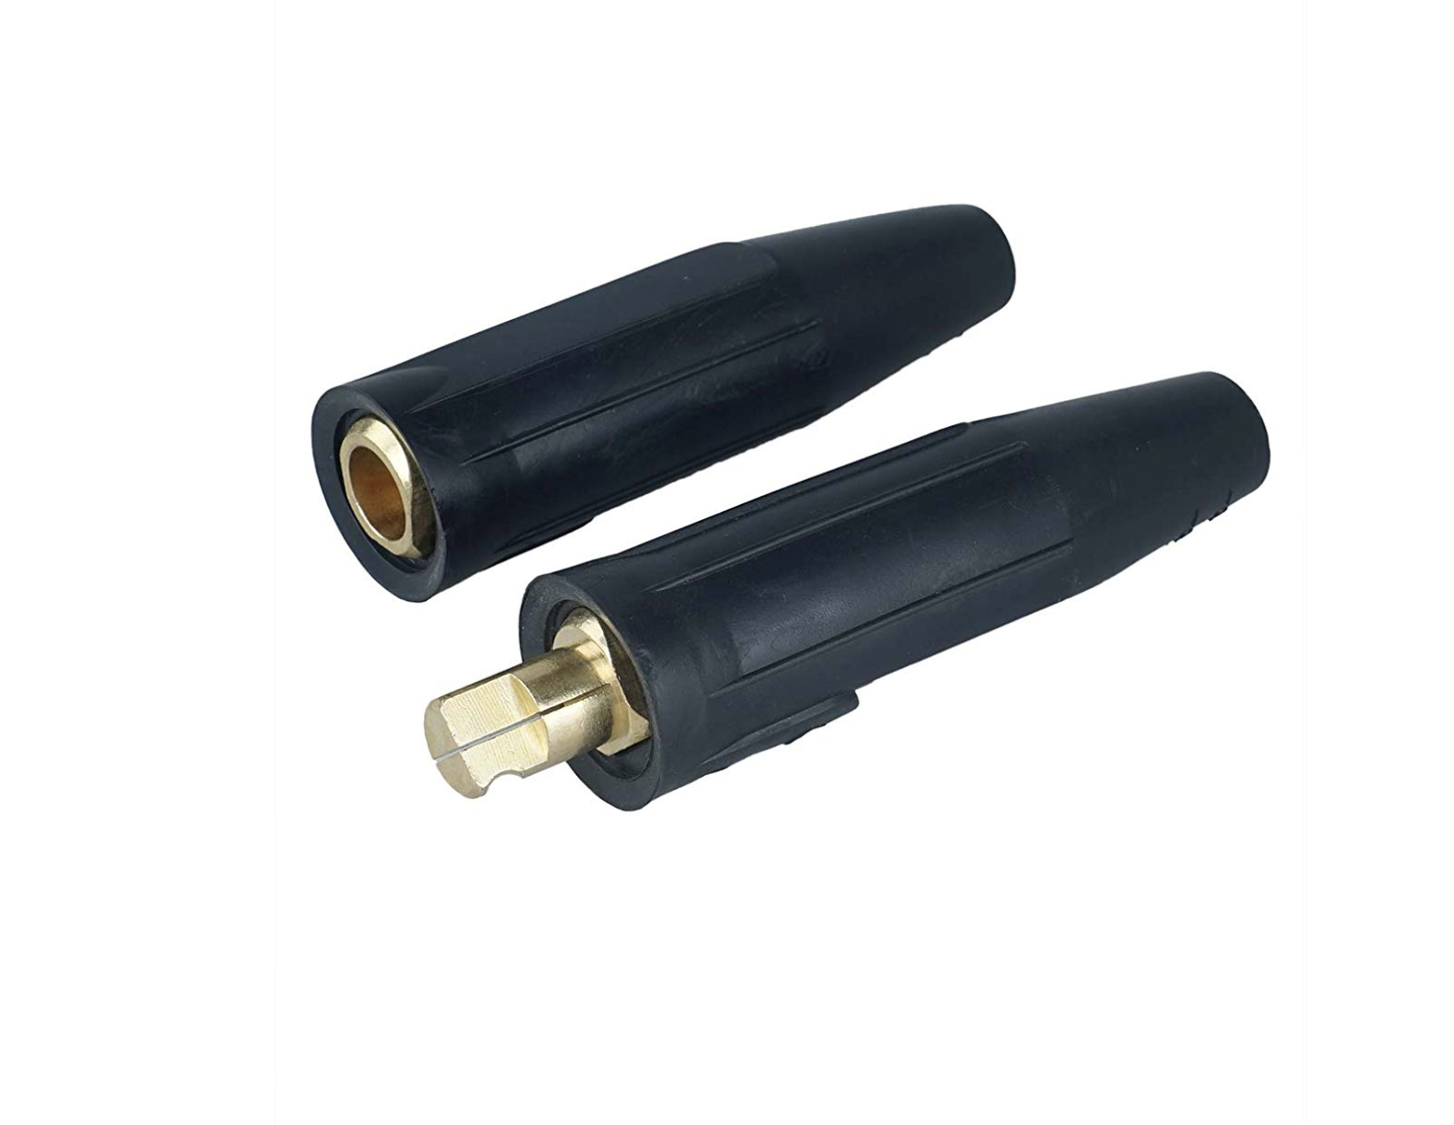

The used Maintenance plugs are provided by Lissam. They are 500A rated welding cable quick connectors. They will be connected between each 2 adjacent battery pack segment in series. A total of 3 pairs (male-female will be used).

|  |  |
| --- | --- |
| Wire type | Extra flexible PVC battery cable (12Volt planet) |
| Continuous current rating: | 500A |
| Cross-sectional area | 95 mm² |
| Maximum operating voltage: | 240VDC |
| Temperature rating: | 70 °C |
| Wire connects the following components: | Batteries, AIRs, Anderson connector, motor controller & motor |

*Table 3.5 Wire data of company 12Volt Planet, 95 mm²*

|  |  |
| --- | --- |
| Wire type | Mil Spec |
| Continuous current rating: | 20A |
| Cross-sectional area | 0.205 mm² |
| Maximum operating voltage: | 100VDC |
| Temperature rating: | 150 °C |
| Wire connects the following components: | Cell and BMS |

*Table 3.6 Wire data of company A, 0.205 mm²*

### **Charging / Chargers**

The accumulator pack will be removed from the car to be charged in the charging area through anderson connectors connected to Elcon’s charger.

The BMS will be connected during charging to monitor the battery pack. Additionally, the charger has multiple protective functions. Appendix

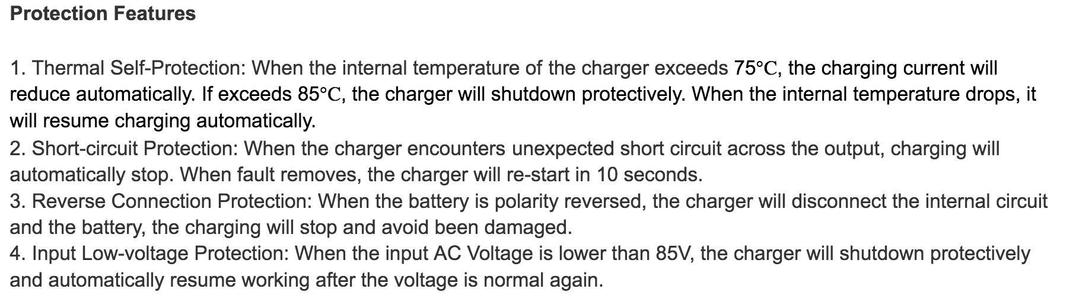

An ESO will be staying in the charging area as well to manually stop the charging in case of any detected errors.

The connector as well as the pack are completely insulated.

|  |  |
| --- | --- |
| Charger Type: | ABC Charger |
| Maximum charging power: | 3kW |
| Maximum charging voltage: | 550V |
| Maximum charging current: | 20A |
| Interface with accumulator | CAN-Bus, proprietary, serial communication... |
| Input voltage: | 230 VAC |
| Input current: | 16A |

*Table 3.6 General charger data*

### **Mechanical Configuration/materials**

Describe the concept of the container, show how the cells are mounted, use CAD-Renderings, show data regarding materials used, etc.

The battery pack is designed from sheet metal steel for its body and its internal walls. It has Nomex sheet adherent to steel for insulation.

Cells are mounted as shown; divided between 4 segments.

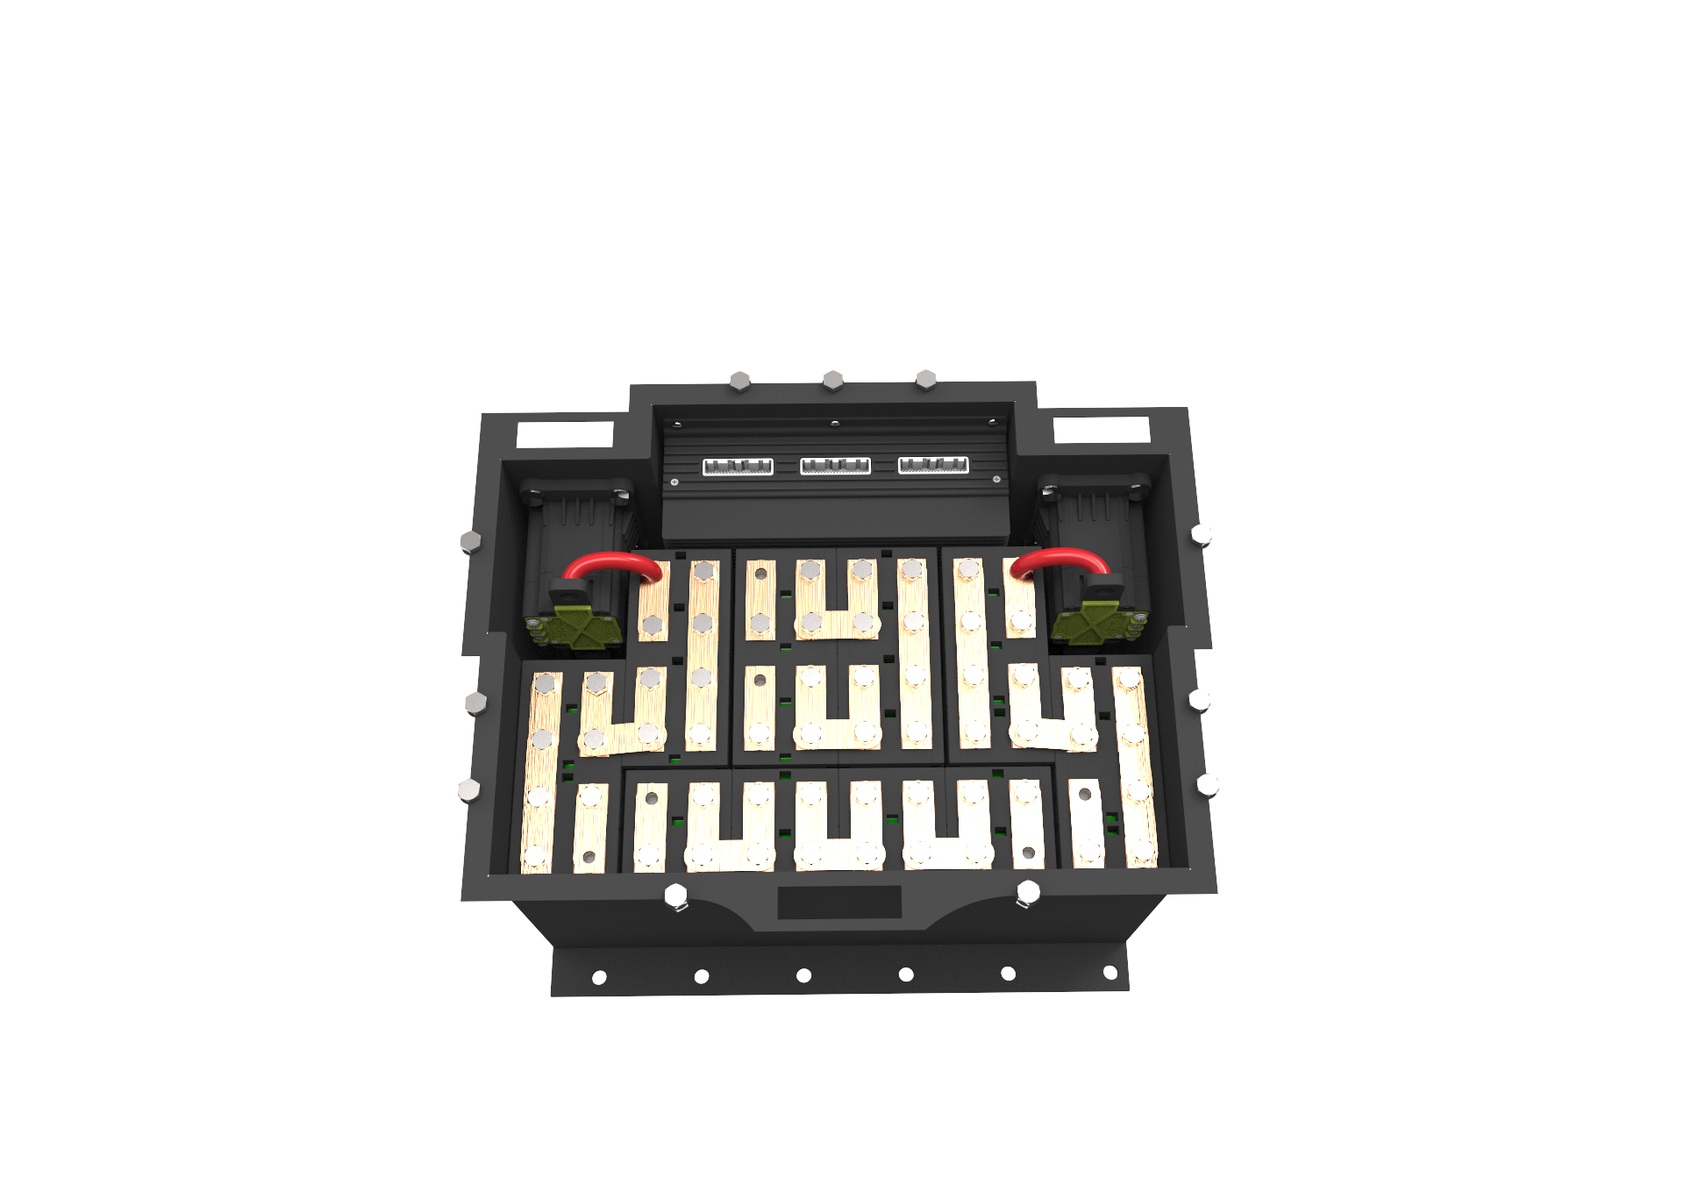

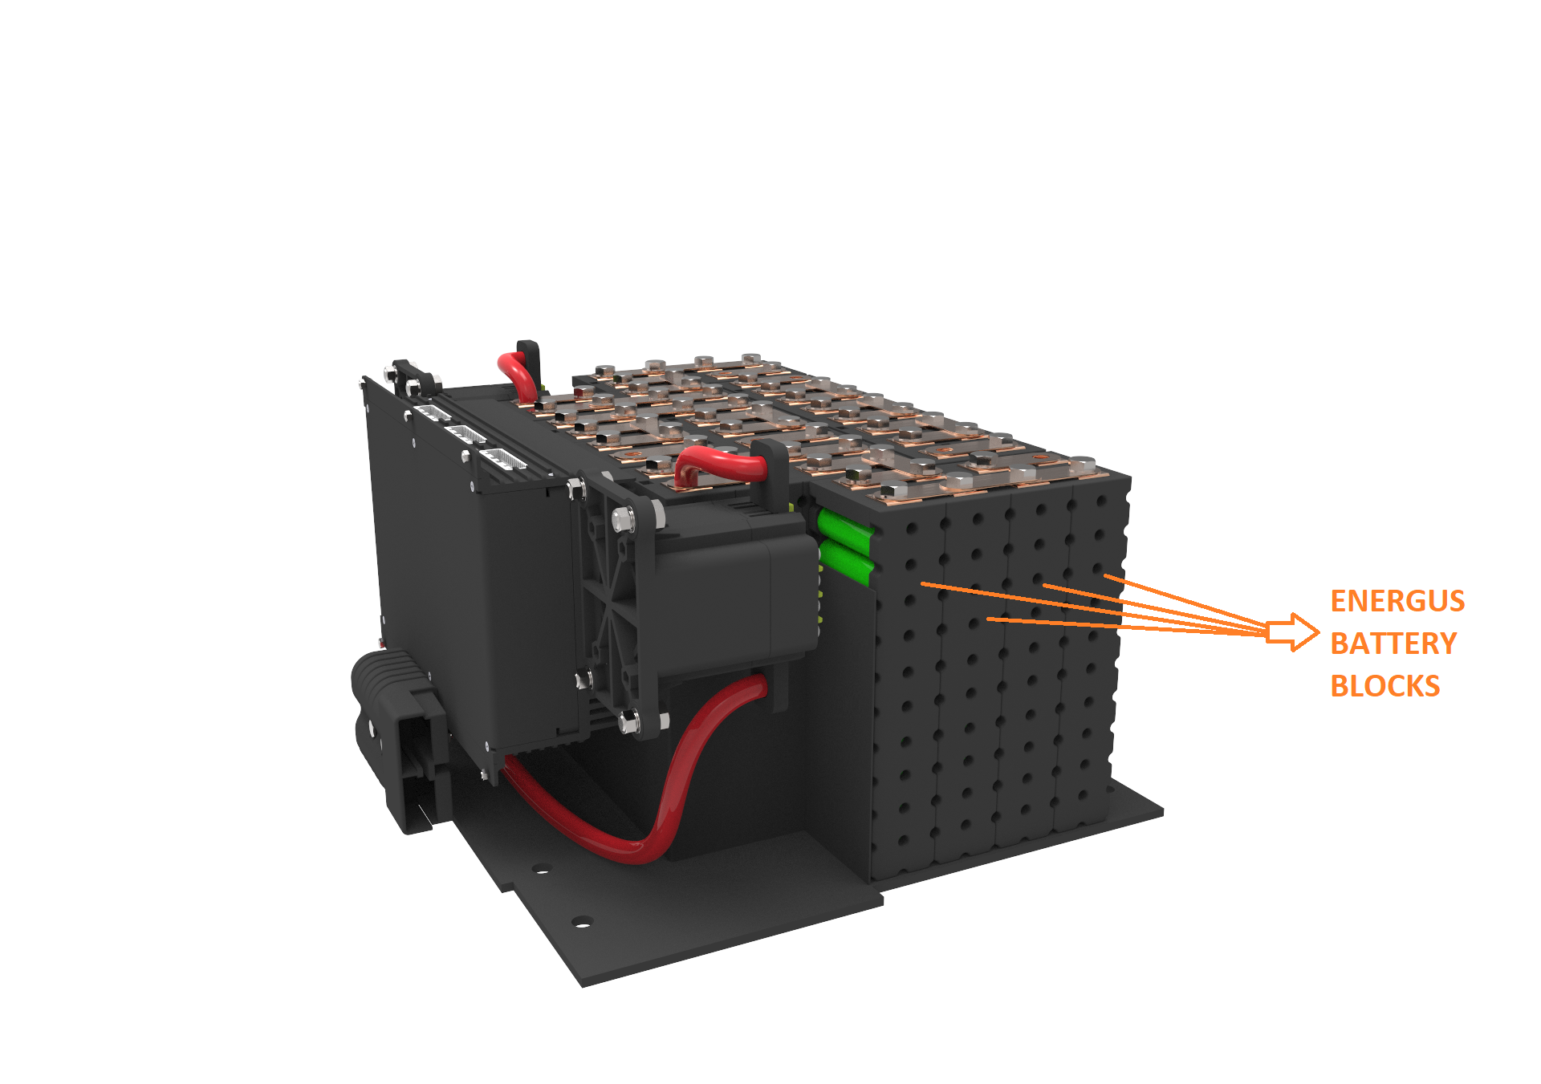

### **Position in car**

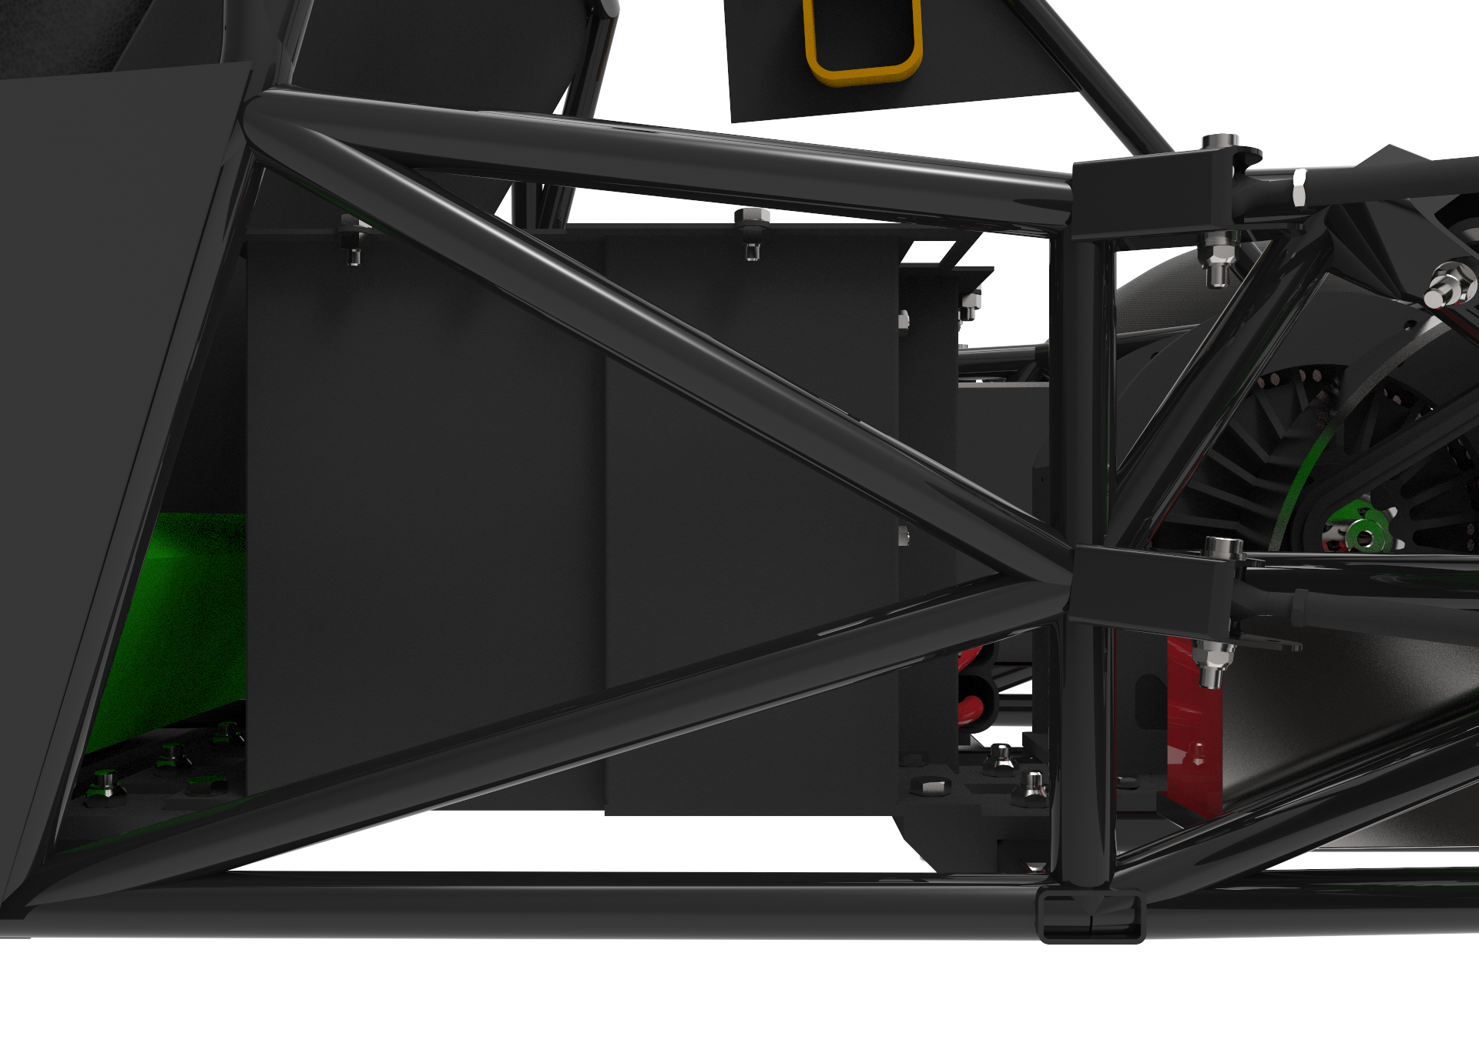

## **Accumulator pack 2**

There is no second accumulator pack as all the components are positioned in one pack with 4 segments.

# **Energy meter mounting**

## **Description**

The energy meter will be placed on top of the battery pack to allow for easy routing of the main battery current carrying wire, but we’re still waiting on data on the energy meter as dimensions and the type of connections that are required by the competition.

## **Wiring, cables, current calculations, connectors**

No data is available on the energy meter yet.

## **Position in car**

no data is available on the energy meter yet.

# **Motor controller**

## **Motor controller 1**

### **Description, type, operation parameters**

The used motor controller is a ready to drive type, it receives an input from the APPS directly to operate the motor and it is used to limit the motor’s drawn current to 550A.

|  |  |
| --- | --- |
| Motor controller type: | SigmaDrive PMT465L |
| Maximum continuous power: | 26.4kW |
| Maximum peak power: | 20.64KW for 10s |
| Maximum Input voltage: | 67.2VDC |
| Output voltage: | 48VDC |
| Maximum continuous output current: | 250A |
| Maximum peak current: | 650A for 60s |
| Control method: | PWM |
| Cooling method: | Air |
| Auxiliary supply voltage: | N/A, the motor controller doesn’y need auxiliary supply |

*Table 5.1 General motor controller data*

### **Wiring, cables, current calculations, connectors**

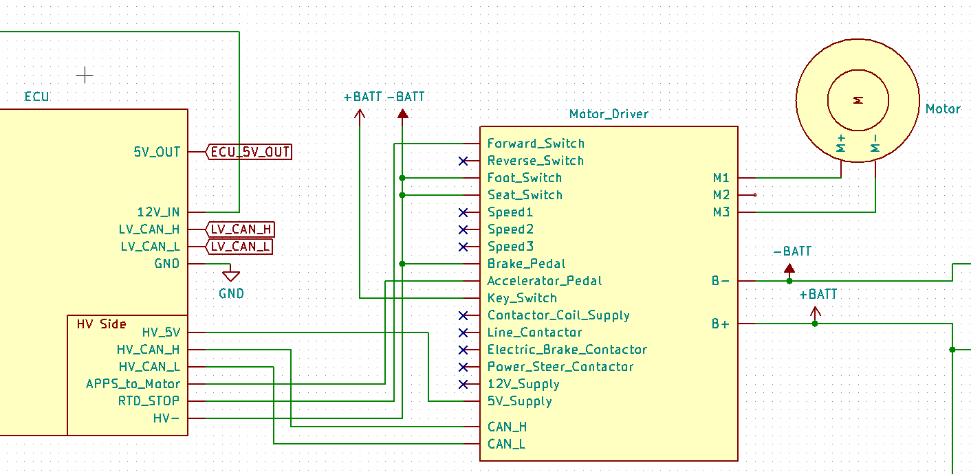

The motor controller is connected directly to the output of the accumulator after the AIRs through Anderson connectors and the motor is connected directly to the motor controller through circular lugs.

|  |  |
| --- | --- |
| Wire type: | Extra flexible PVC battery cable (12Volt planet) |
| Current rating: | 150A |
| Maximum operating voltage: | 57.6V |
| Temperature rating: | 70 °C |

### **Position in car**

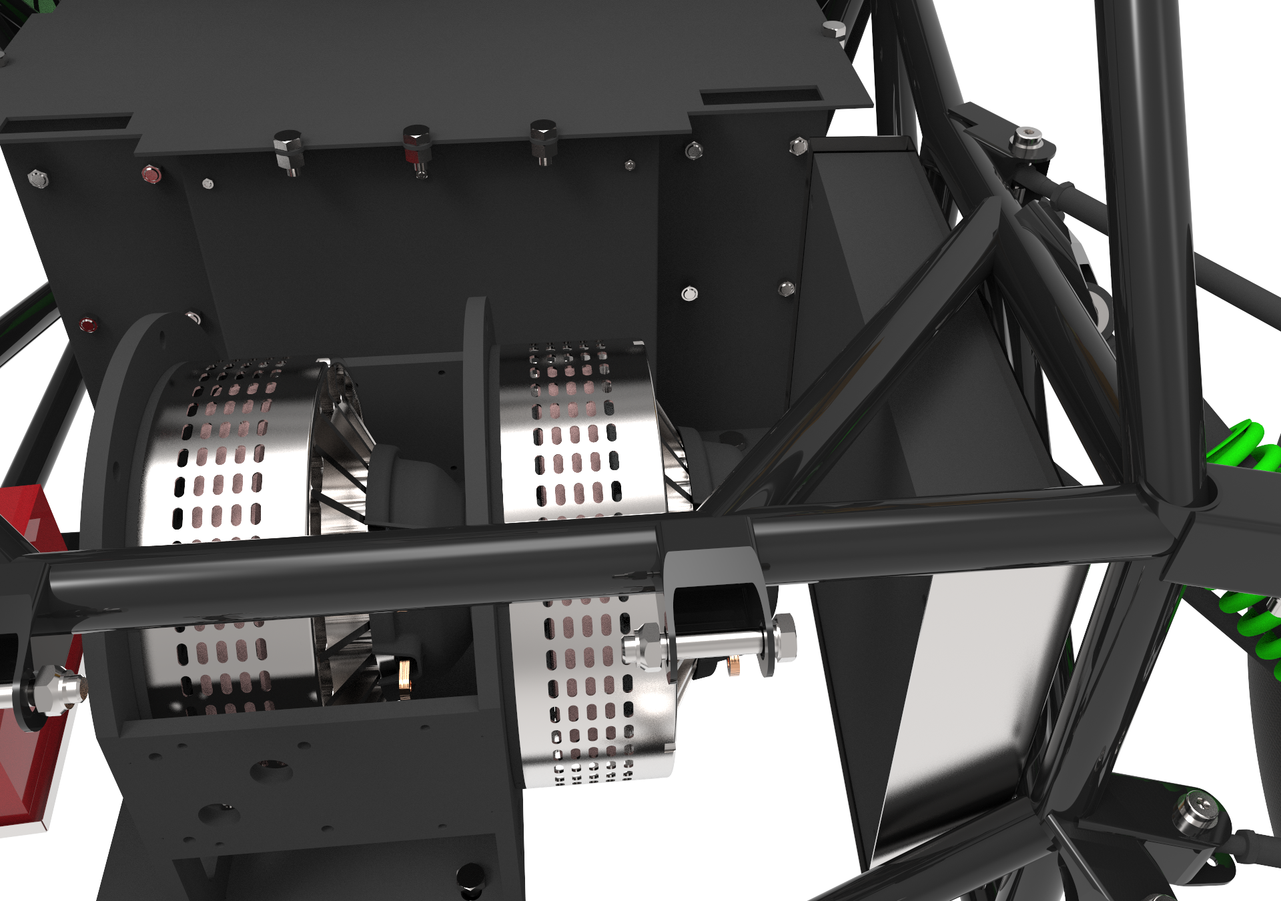

Shown in figure is the interconnection between the motor, motor controller and the battery pack through the Anderson SB350 connector.

## **Motor controller 2**

The vehicle only has one motor controller.

# **Motors**

## **Motor 1**

### **Description, type, operating parameters**

The used motor is a coupled, DC brushed motor from Lynch. 2 identical motors are positioned on the same shaft; connected in parallel as seen in the attached motor diagram. The motor doesn’t require a casing, it is fixed through its shafts and connected to sprockets.

|  |  |
| --- | --- |
| Motor Manufacturer and Type: | Lynch LEM 127 2*2 |
| Motor principle | Axial gap DC brushed motor, |
| Maximum continuous power: | 7.9kW |
| Peak power: | 16 kW |
| Input voltage: | 48VDC |
| Nominal current: | 400A |
| Motor’s minimum voltage | 45.66 V |
| Peak current: | 550A for 10 seconds |
| Maximum torque: | 56Nm |
| Nominal torque: | 31.5Nm |
| Cooling method: | Air |

*Table 6.1 General motor data*

* *Give a plot of power vs. Rpm including a line for nominal and maximum power*

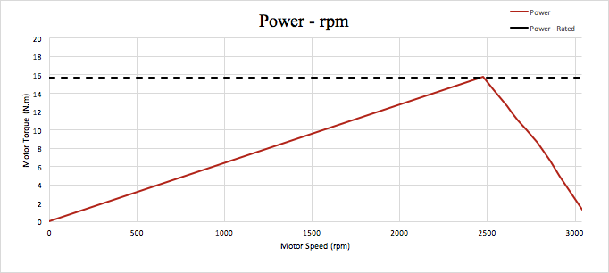

* *give a plot of torque vs rpm including a line for nominal and maximum torque*

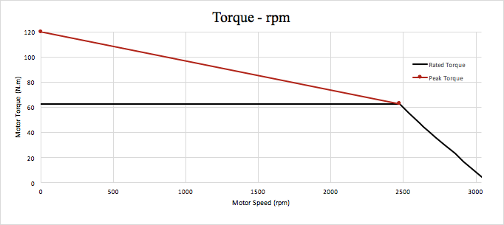

### **Wiring, cables, current calculations, connectors**

As shown in the figure, the motor is positioned next to the motor controller behind the seat; reducing the needed cable’s length to a minimum. It is connected with Cables to the motor controllers through Copper tube .

The table provided by the company Lynch (which could be found here) shows the data of one of the coupled motor.

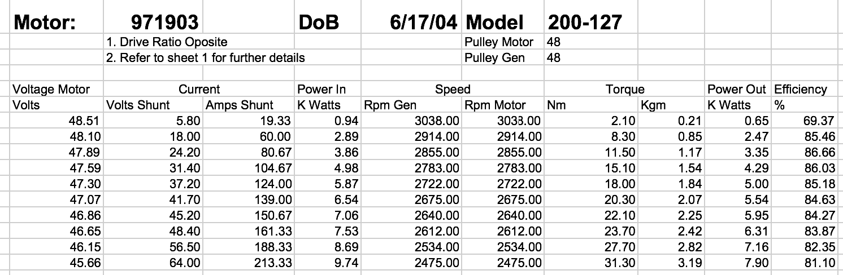

Multiplying the highest current by 2:

213*2= shows that the maximum operating (nominal current) is 426A.

The motor could operate at higher values however the motor controller will limit the current’s value to 550A.

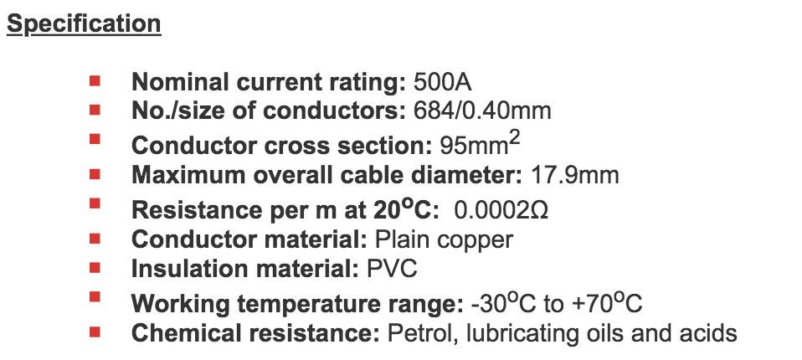

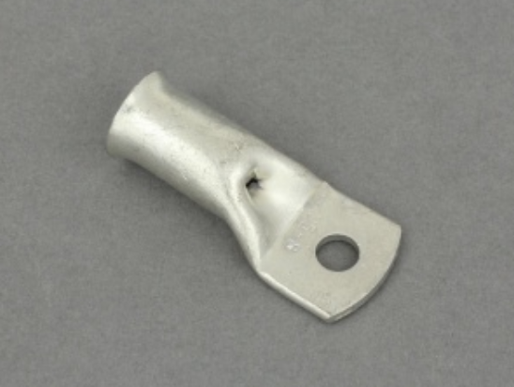

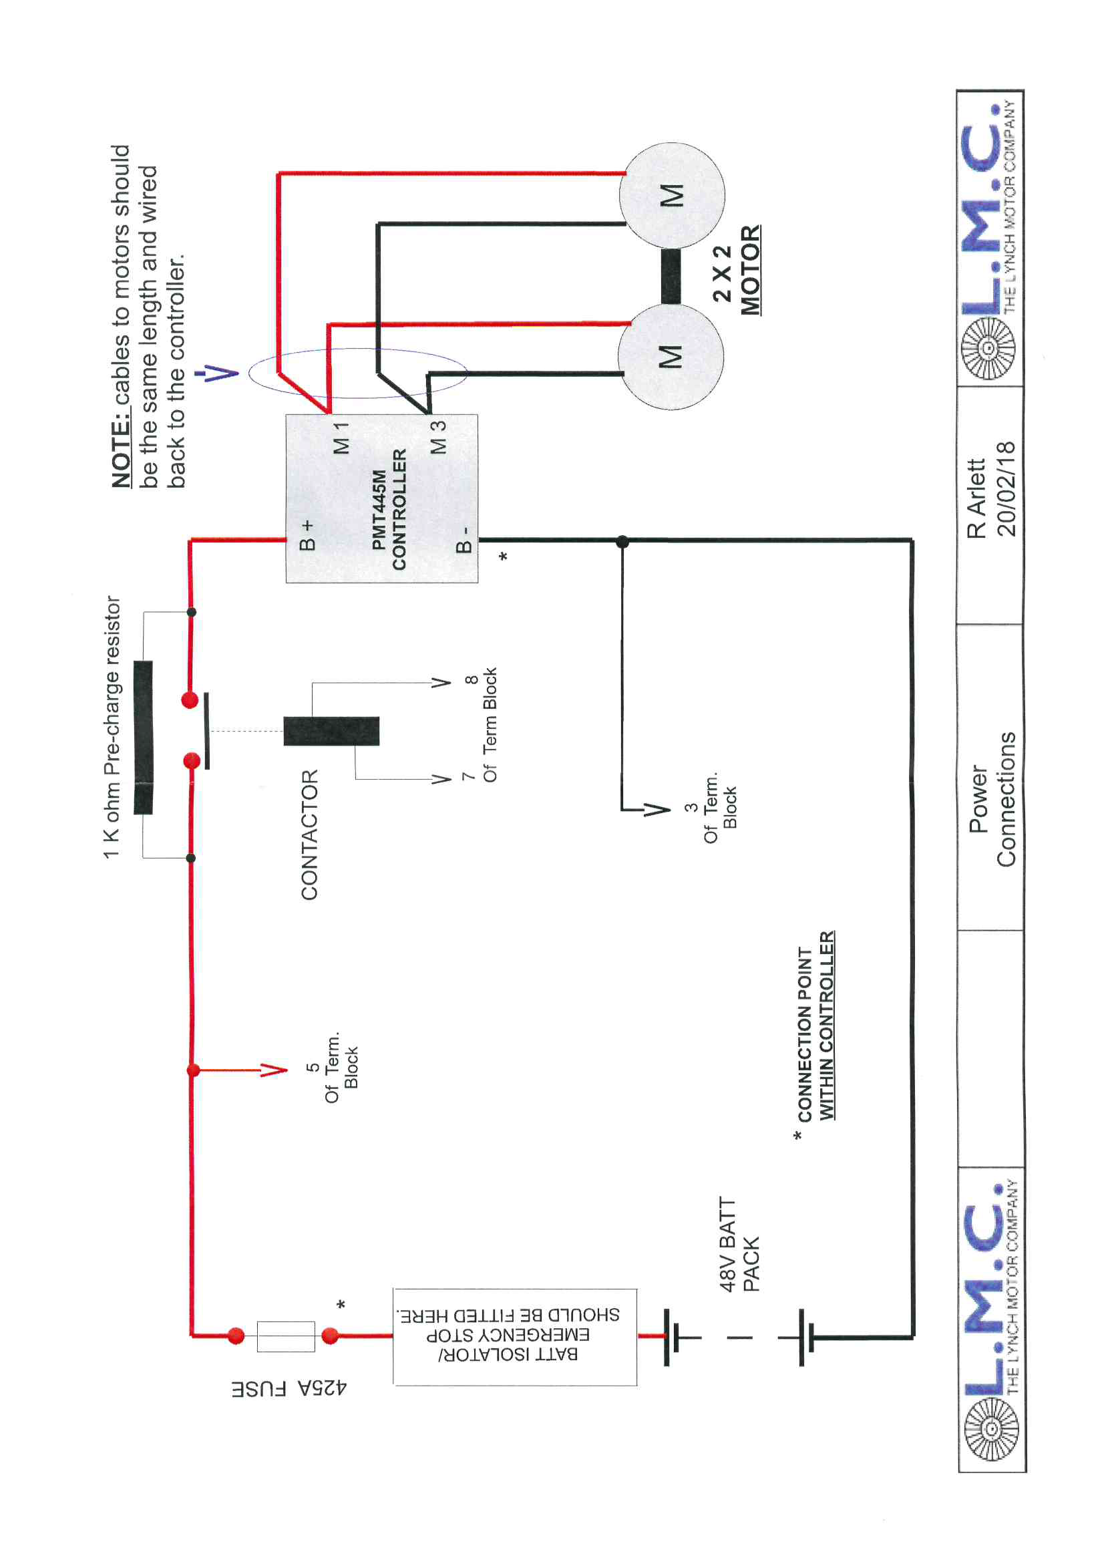

### **Position in car**

## **Motor 2**

A coupled centralized motor is used with no additional motors in use. This section doesn’t apply on the vehicle.

# **Torque encoder**

## **Description/additional circuitry**

The torque encoder used in a Curtiss Wright SRH302 which has dual output each with its independent supply and ground lines and different positive slopes from each other and its signal and supply connected directly to the ECU which calculates the signal to send to the motor driver based on these 2 signals.

If an implausibility is detected the ECU reduces the signal to the motor drive to 0 and the vehicle goes out of ready to drive mode.

|  |  |
| --- | --- |
| Torque encoder manufacturer and type: | Curtiss Wright SRH302 |
| Torque encoder principle: | Hall Effect |
| Supply voltage: | 5V |
| Maximum supply current: | 20mA |
| Operating temperature: | -20..180 °C |
| Used output: | 0.2-4.8V |

*Table 7.1 Torque encoder data*

## **Wiring**

The SRH302 comes with no connector just 6 wires which are crimped to 2 waterproof 3 way connector each output with its supply and ground lines which are routed to the ECU directly

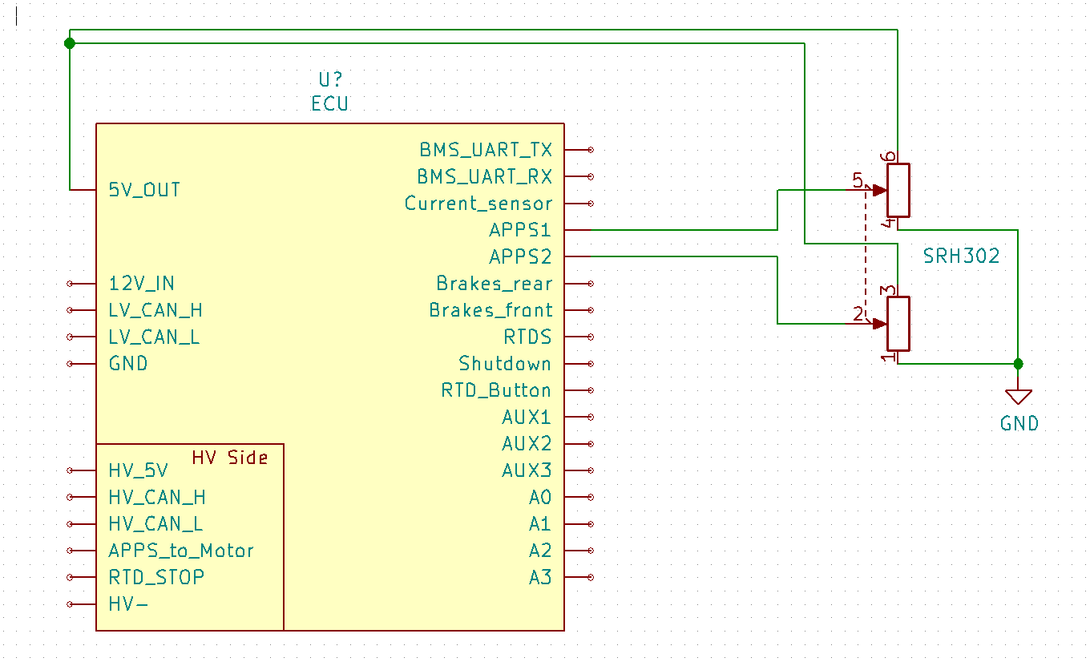

## **Position in car/mechanical fastening/mechanical connection**

It attaches to the pedal box as per the pedal box manufacturer’s recommendation.

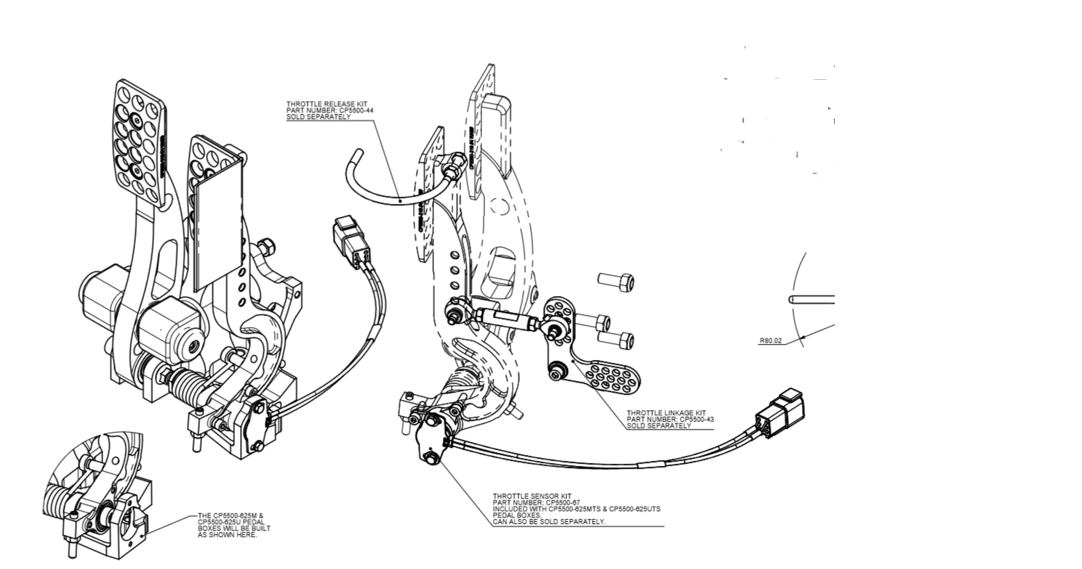

# 

# **Additional LV-parts interfering with the tractive system**

## **LV part 1**

The ECU’s PCB has a galvanically isolated section that connects to the motor controller to provide the Accelerator signal, the ready to drive signal, and an isolated CAN bus interface.

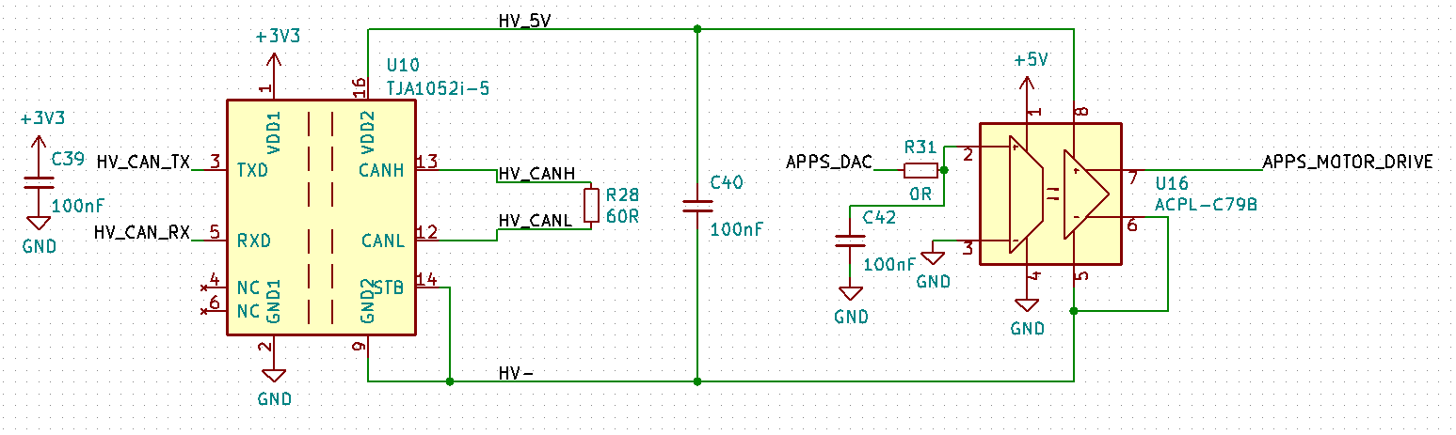

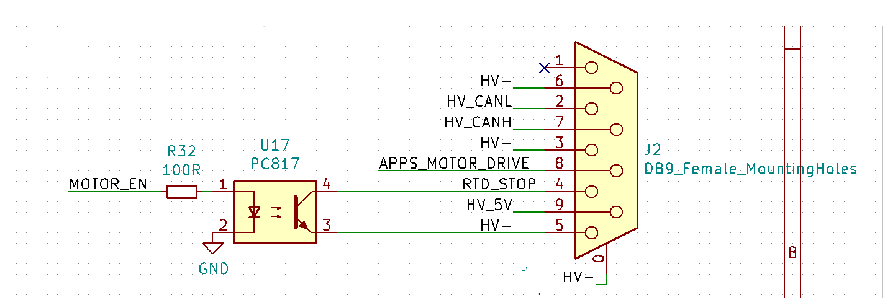

### **Description**

TJA052i-5 is galvanically isolated CAN Transceiver IC with 5 KV of isolation

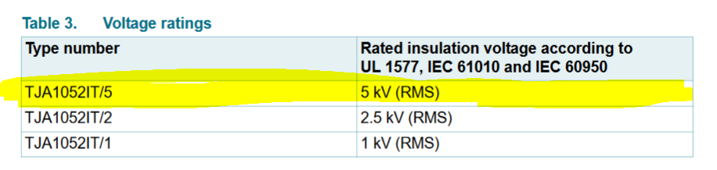

ACPL-C79B is a galvanically isolated analog amplifier used for the analog motor drive signal.

PC817 is an optocoupler with 5 kV of isolation, it’s used for pulling the forward pin on the motor driver to HV- which puts the vehicle in ready to drive mode.

The ECU PCB is designed to have enough clearance between the HV side and the LV side

### **Wiring, cables,**

A DB9 connector is used to connect the ECU to the motor controller directly using shielded cable.

### **Position in car**

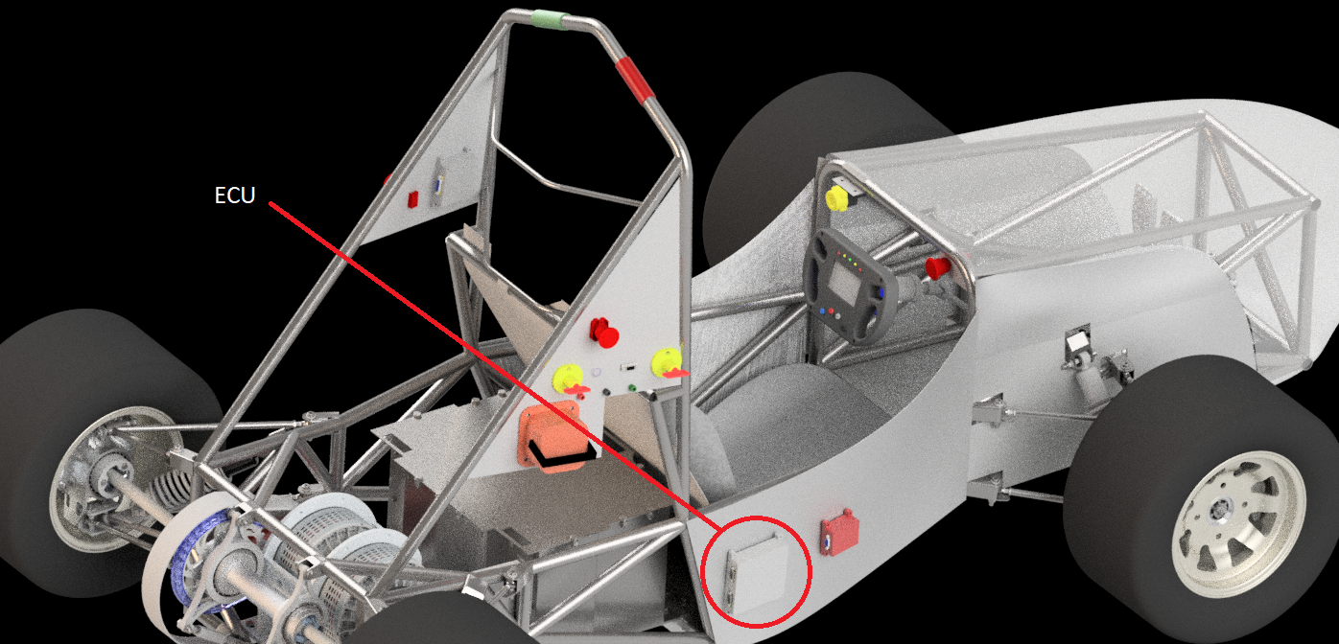

## **LV part 2**

…

# **Overall Grounding Concept**

## **Description of the Grounding Concept**

TS is galvanically isolated from the LV system, they share no signal except through relays and optically isolated components.

All PCBs that combine LV and HV are designed within the required clearance for the voltage levels we use, and all HV wires are routed through orange conduit which is fixed to the chassis of the car.

## **Grounding Measurements**

Distance measurement between all TS and LV signals and supplies to ensure 100 mm of separation.

Resistance measurement between all TS signals and LV signals and supplies to ensure at least 35k Ohm of resistance.

# **Firewall(s)**

## **Firewall 1**

### **Description/materials**

Describe the concept, layer structure and the materials used for the firewall.

The low resistance path through the firewall is ensured by having multiple welded point in the chassis to act as ground connection and the chassis is the main ground node.

### **Position in car**

Provide CAD-renderings showing all relevant parts

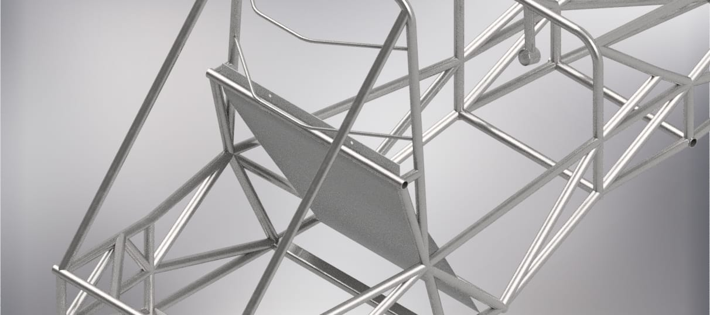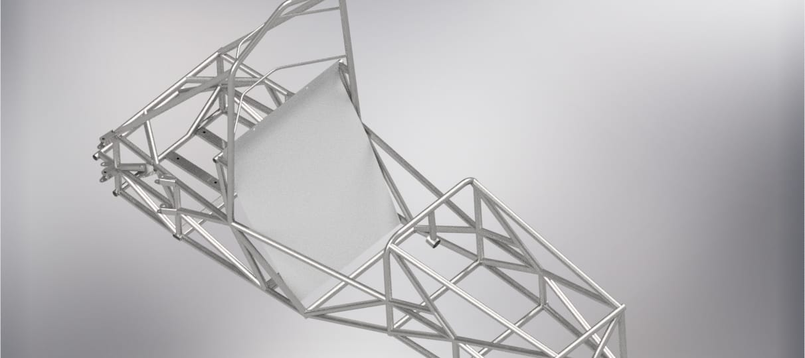

## **Firewall 2**

# **Alternative Fuel Systems and Hybrids**

The vehicle is an EV with no Alternative fuel systems. This section does not apply.

## **Drive By Wire Throttles**

### **Description**

Describe the drive by wire throttle if one is present, how it is controlled, how it is operated and any strategies use to ensure that it fails in a benign manner

### **Position in car**

Provide CAD-renderings showing all relevant parts. Mark the parts in the rendering, if necessary.

## **Gaseous Fuel**

### **System Description**

Describe the gaseous fuel system if appropriate including the fuel type, the fuel storage system, certification standards and the systems used to ensure that any failure is benign.

### **Position in car**

Provide CAD-renderings showing all relevant parts. Mark the parts in the rendering, if necessary and showing clearly that the required level of protection is respected

## **Hybrids**

### **System Description**

Describe any hybrid systems and in particular how the interaction between the combustion engine and electrical systems work and any safety critical aspects including the control system that is used and the measures taken to ensure that it fails in a benign manner.

### **Position in car**

Provide CAD-renderings showing all relevant parts. Mark the parts in the rendering, if necessary.

## **Alternative Liquid Fuels**

### **System Description**

Describe the measures that have been taken as appropriate to deal with any issues posed by alternative liquid fuels, for example what sealing material is used etc.

### **Position in car**

Provide CAD-renderings showing all relevant parts. Mark the parts in the rendering, if necessary.

## **Other Systems**

### **System Description**

Describe any other powertrain systems on the vehicle that could have safety implications on the operation of the vehicle and the measures that have been taken to ensure that any failure is benign.

### **Position in car**

Provide CAD-renderings showing all relevant parts. Mark the parts in the rendering, if necessary.

# **Appendix**

**Numbering according to chapter 1 to 10**

A datasheet for motor controller one for example has to have the numbering 10.5.1.1